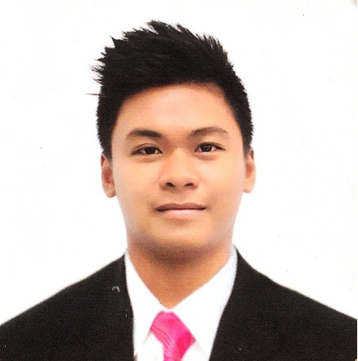

Melvin Reotutar Quitoriano
(FIRST NAME MIDDLE NAME LAST NAME)

119 Rabe Street, Cabuloan, Santa Catalina Ilocos Sur 2701
(+63) 929 188 3212

Melvinquitoriano13@gmail.com

Objectives
Seeking a deserving profile in the hospitality sector, where I can deliver my expertise and innovate my hospitality skills, while maintaining the integrity and work ethics of the working environment, thereby maintaining the reputation of the restaurant and to work with passion and responsibly and to where I could practice all my knowledge to the restaurant and I could develop my personality as a restaurateur. (I want to have training in F&B department since I am a Hotel and restaurant Management graduate).

Educational Background
June 9, 2014 – June 5, 2018 University of Northern Philippines (College)
Location: Tamag, Vigan City, Ilocos Sur

- Bachelor of Science in Hotel and Restaurant Management
- Active member of the University of Northern Philippines Bartender’s Club
- Active member of the Pro-Fraternity in University of Northern Philippines
- Active member of the Society of Hospitality and Tourism Students (SHATS) and Hotel and Restaurant Administration Students Organization (HRASO)

June 11, 2010 – March 15, 2014 Divine Word College of Vigan (Secondary)
Location: Vigan City, Ilocos Sur, Philippines

Co-Curricular Activities
- Bartending activities inside and outside the school, we offer our services in exchange of money.
- Every week, the Pro-Fraternity Organization shall organize a tree planting activity and school cleaning.
- Every year, I compete in Bartending and Pasta Cooking in our school’s events (HRASO Fex).
Training
Hotel Linda, February 11, 2015 – May 13, 2015, F&B Waiter/Catering Services
Location: Jose Singson, Vigan City, Ilocos Sur, Philippines
- Busting out plates and utensils, waiting tables, catering services inside and outside the hotel.

Fort Ilocandia Hotel and Resort, May 3, 2016 – June 10, 2016, On – The – Job Trainee
Location: Brgy. 37 Calayab, Laoag City, Ilocos Norte, Philippines

- Concierge, driving golf carts and vehicles in and out of the hotel.
- F&B Western and Chinese kitchen, enhancing my knife skills and baking knowledge.
- F&B Red8 Restaurant (Chinese Restaurant), enhancing my knowledge in table set ups, waiting tables and etc.

Patong Merlin Hotel and Resort, December 13, 2017 – March 31, 2018, Pool Server
Location: 4 Thaveewong Rd, Patong Beach, Kathu, Phuket 83150, Thailand
- F&B Pool waiter and Bartender, delivering orders in the pool side of the hotel, making smoothies, cocktails and mocktails.

The Meritage Resort and Spa, May 27, 2019 – March 27, 2020, F&B Server/Banquets Server
Location: 875 Bordeaux Way, Napa, California 94558

- Serving food and beverage for events, ensuring excellent and professional client service at all times, setting-up and resetting specific function activities.

