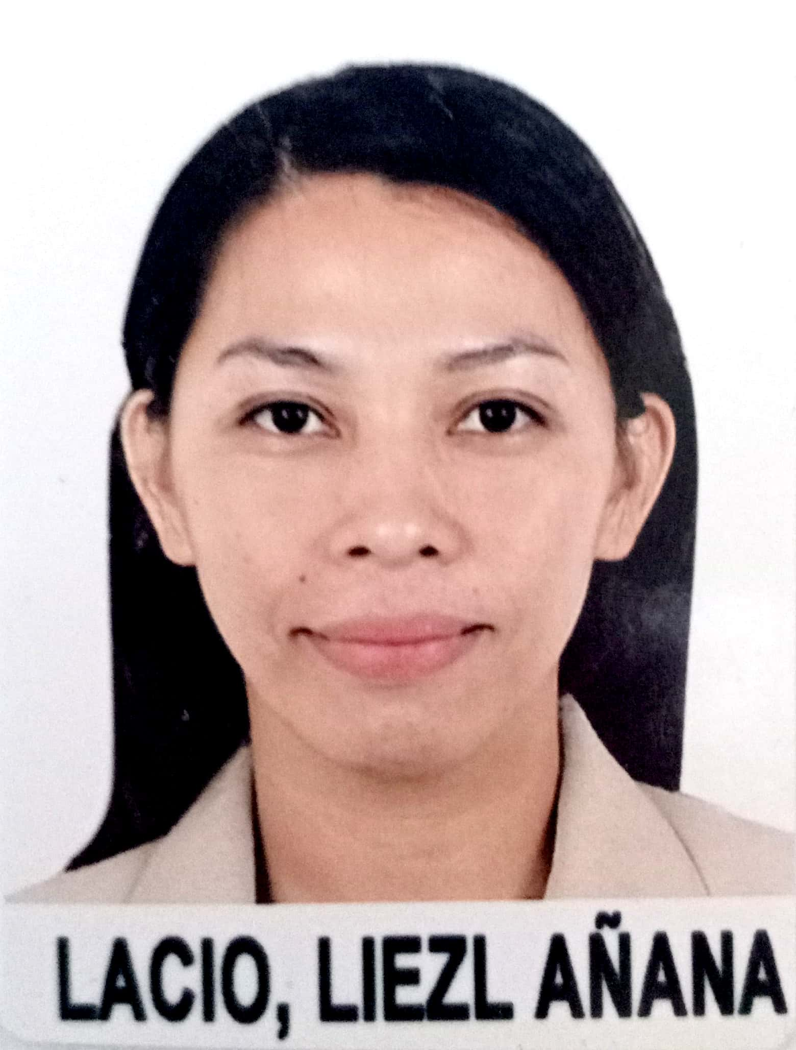
LIEZL A. LACIO
Linaon, Cauayan, Negros Occidental, Philippines 6112
Contact #: +63 9358776926
Email Address: liezllacio1215@gmail.com

CAREER OBJECTIVES

I would like to utilize my skills and experience with any vacancies position in your organization and to share and expand my knowledge more.

PERSONAL INFORMATION

Date of Birth February 15,1995
Place of Birth Linaon, Cauayan, Negros Occidental, Philippines
Gender Female
Nationality Filipino
Civil status Single
Religion Catholic
Age 26 years old
Height 5'3"
Weight 51 kg.

EDUCATIONAL BACKGROUND

Primary Linaon Elementary School (SY 2006-2007)
Secondary Florentine Caña Recto Memorial National High School (SY 2010-2011)
Tertiary Bago City College (Bachelor of Science in Elementary Education ) (SY 2018-2019)

SPECIAL SKILLS

Computer Literate
Self-motivation
Ability to work under pressure

CERTIFICATE AND TRAINING
- Certificate of Passing(Teacher) PRC (2020)
- Teach English as a Foreign Language 120 hours (2021)
- Contact Center Services NC2 160 hours ( 2021)
- Introduction of Food and beverage Service & Food Processing. COC- 2021

WORK EXPERIENCE

Househelper/caregiver Emelda Sonza Residence Sum-ag,Bacolod City, Philippines (2012-2014)

Student Assistant Bago City College Registrar Office, Classroom (2016-2018)
Bago City, Philippines

English Tutor Neighbor's house Cauayan, Negros Occidental, Philippines ( 2021)

REFERENCE

Mrs.AMOR VERBA G. SAUSA Mr.Joseph Chua
Public Elementary Teacher Dadis Catering and Flower arrangement Owner
La Carlota City, Philippines La Carlota City, Philippines
+63 9997843718 +639471794768

Mr.Robert B.Sonza
Call Center Agent
Sum-ag Bacolod City, Philippines
+639380469757

