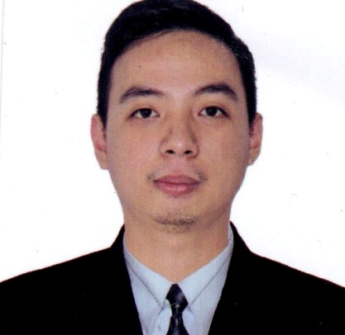
RODOLFO T. CALMA JR.

Address:28 Samar st.Bago-bantay,Quezon city
Mobile:09614509612 Email:jhaycalmajr@gmail.com

EMPLOYMENT SUMMARY

- 4 years experienced in Royal Catering Services in Abu Dhabi UAE who is attentive and well-versed in all local state and federal food handling laws. Adept at preparing banquets assisting in special food presentations and making sure that food preparation and presentation areas are clean and we cater all types of big events in the region.

- 5 years sales experience as motivated Sales Associate, independent worker with high energy and great communication skills. Reliable and friendly professional able to work with little oversight and collaborate in team environments.

- 4 years experienced as service crew on KFC Philippines. Greet the customers, take orders, cook, and inform the superior in our remaining products and also doing a inventory.

OBJECTIVE : To be part of an organization where I can utilize to the fullest potential personal skills and knowledge, while acquiring opportunities for my growth personally and professionally so that I can contribute towards its development and success.

Work Experience:

Organization Position Date
Royal Catering llc. | Waiter/ADNOC-HQ (project) | 2017-2020
Royal Catering llc. | Waiter/Banquet,Events | 2016-2017
Rustan`s Dept. Store | Sales Associate | 2012-2016
KFC Philippines | Waiter /Cook | 2009-2012

Royal Catering Services LLC March 2016 – April 2020

Key Responsibilities

- Manage Buffet

Food attendants organize and plate buffet items, break down and clean buffets, and refill foods on the buffet as necessary.

- Stock Food Service Stations

Food attendants resupply napkins, cutlery, dishes, and condiments on food service stations as needed during meal service.
- Prep Meals and Drinks

Food attendants assist with meal prep, making and serving items such as salads, in-house dressings, and specialty drinks.
- Answer Phones

Food attendants answer phones and take delivery orders from customers.

- Clean Work Areas

Food assistants clean all dining, food service, and kitchen areas before, during, and after meal service.

- Follow Food Safety Guidelines

At all times, food assistants follow all food safety standards and restaurant sanitation regulations. This includes washing hands, emptying trash, and cleaning dining areas.

- Speak to Customers

Food attendants answer customer questions and make menu suggestions to sell more items.

Sales Associate
Rustans Shangri-la Shaw blvd., Mandaluyong City July 6, 2012 – March 20, 2016

Key Responsibilities:

- Greeting the customer who enters the shop.

- Be involved in stock control and management.

- Assisting shoppers to find the goods and products they are looking for.

- Being responsible to processing cash and card payments.

- Stocking shelves with merchandise.

- Answering queries from customers.

- Reporting discrepancies and problems to the supervisor.

- Working within details established guidelines, particularly with brands.

- Giving advice and guidance on product selection to customers.

- Keeping up to date with special promotions and putting up displays.

- Receiving and storing the delivery of large amounts of stocks.

Sales Associate
Baby Company SM North Edsa Sales May 5, 2011 – June 30, 2012

- Proactively sought out customers to assist across sales floor.

- Enthusiastically conversed with customers about purchases needs and available products.

- Escorted customers to products, answered questions about uses, and made sure all questions were answered and no additional help was needed.

- Prepared for promotions by rearranging stocks, adding signage, and retagging merchandise.

- Recommend appropriate items and direct or lead customers to selections.

- Assist customers with trying on items, finding appropriate sizes, and completing purchases.

Topspot Multi-Purpose Cooperative Service Crew ( KFC Philippines)
E. Rodriguez, Quezon City March 9, 2009 – April 30, 2011

Key Responsibilities:

- Knowledgeable on Restaurant Operations

- Able to provide fast and quality service

- Customer service oriented

- Provide Customer satisfaction

- Perform Highest level of CHAMPS

EDUCATIONAL BACKGROUND

Hotel and Restaurant Services
Datamex Institute of Computer Technology
Recto, Manila
June 2010 - March 2012

CHARACTER REFERENCES
Available upon request

