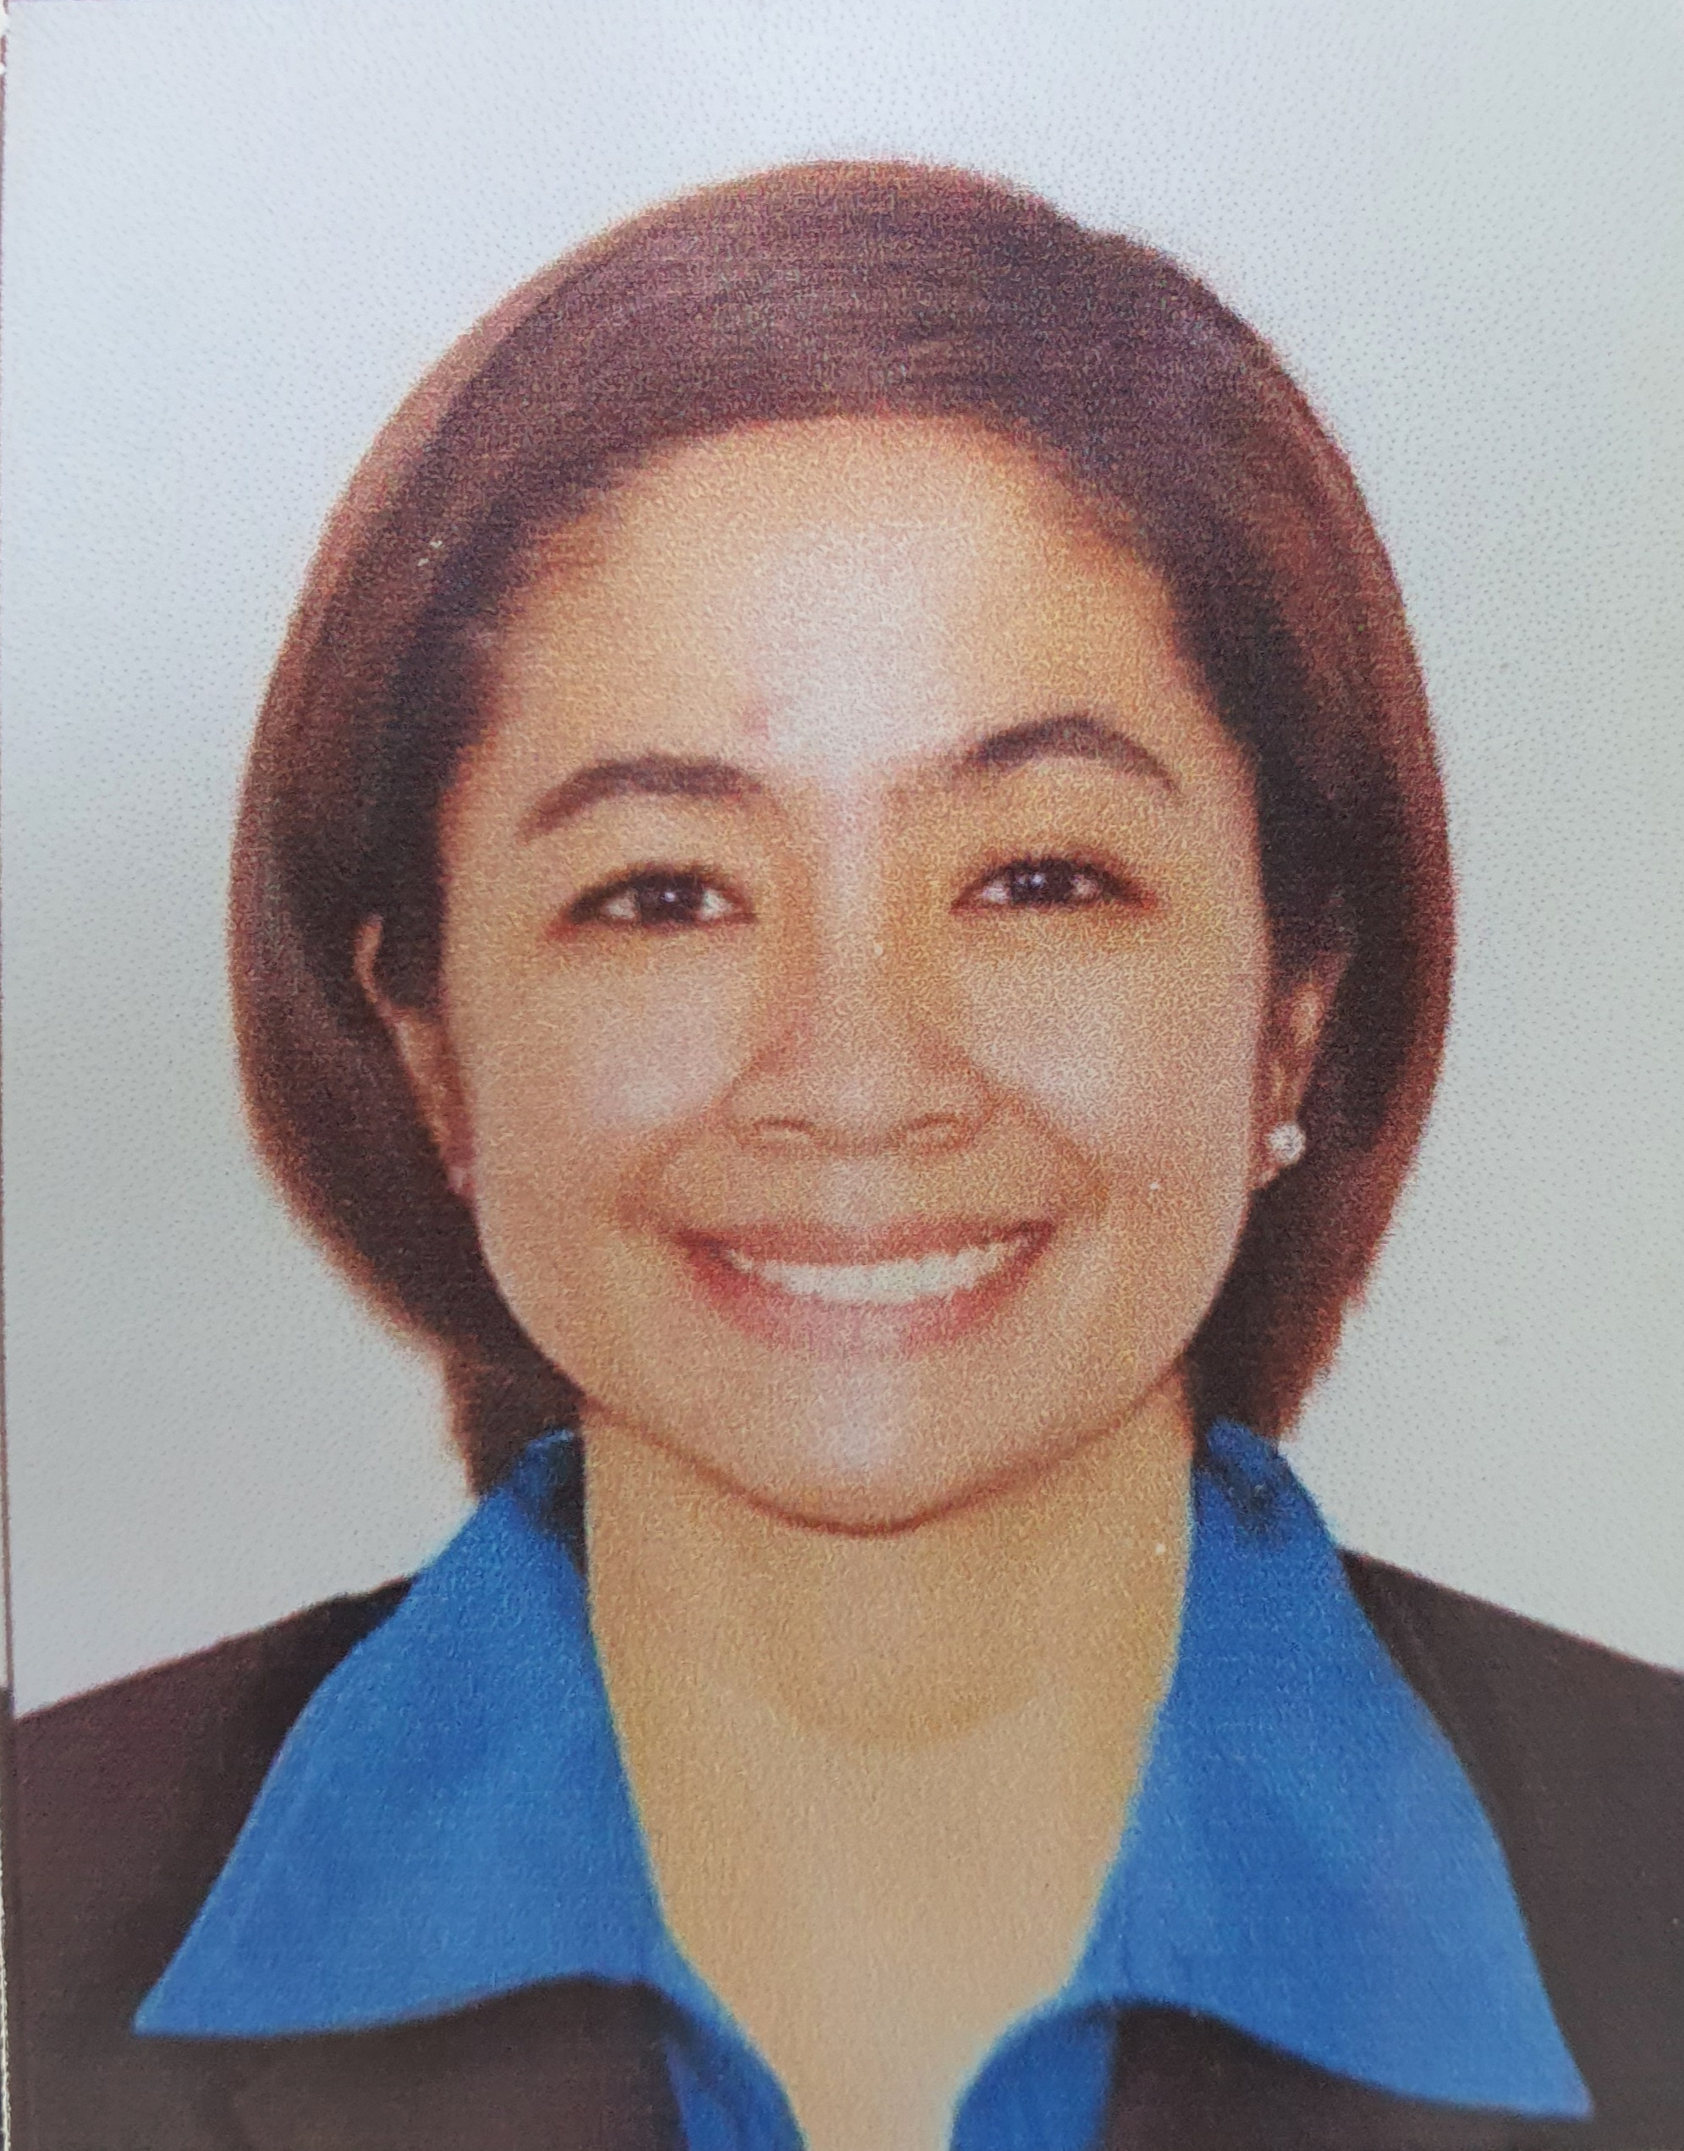 |  |  |  | Jessika Hanna Balais -  Herrero

Experience

March 2019 – Present

• Operating Room Nurse (Day Case Surgery), OPD Nurse •
Experts Medical Center – Muhayil, KSA

Skills and Responsibilities:
- Appointed as head of operating room that caters elective day case surgery (Ophthalmology Department). As the head OR nurse, I make sure that infection control policies and operating room standards are strictly observed, at all times.
- I also perform the roles and responsibilities of a scrub and circulating nurse (OR and Refractive Surgery Unit).

January 3, 2009 – January 15, 2019

• Charge Staff Nurse •
Frams Maternity & Pediatric Clinic, OB – GYN Services and Ultrasound Clinic – Cavite, Philippines

Skills and Responsibilities:
- Proper assessment and validation of complaints of walk in patients through interview, and vital signs taking.
- Provide nursing care to patients such as: vital signs taking and recording, correct drug administration (Intravenous, Intramuscular, oral administration, nebulization) and give appropriate health teachings for future awareness.
- Assist obstetrician in providing maternity care to mother and child.

August 2008 – September 2008

• Nurse Reliever •
Hospital of the Infant Jesus – Sampaloc, Manila

Skills and Responsibilities:
- Assigned with 10 to 12 patients in every shift for admission, monitoring of vital signs, input/output, drug administration, continuity of care, discharge process and other nursing bed side routines.
- Made sure that doctor’s order were clarified before given to patient.
- Observed proper endorsement to the next nurse on duty.
- Made sure that nursing standards and patients’ rights were STILL followed regardless of patient’s demand and staffing.

Education

La Consolacion College – Mendiola, Manila

- Bachelor of Science in Nursing, 2003 – 2007
- GPA – 1.92
- Dean’s Lister, 2nd year
- LCCM Choir Member, 2003
- Student Nurses Association – Batch Representative, 2004 – 2006
- Mother Consuelo Barcelo Organization – Member

St. Joseph College – Baggao, Cagayan Valley

- High school Diploma, 1999 – 2003
- Student Body Organization Representative
- KABSAT (Theatre and Arts) – 4th year High School

San Jose Elementary School, Baggao Cagayan Valley

- Grade school Diploma, 1993 – 1999
- Student Body Organization Representative

St. Joseph College – Baggao, Cagayan Valley
- Preparatory School, 1991 – 1993

Eligibility
- Saudi Commissions for Health Specialties – Licensed Nurse Specialist, 2019 to present
- Philippine Licensure Examination for Nurses – Registered Nurse, 2007 to present

Proficiencies
- Good communication skills (written and verbal)
- Computer Literate (MS Office, Internet)
- Leadership skills
- Interpersonal skills

Character References

Dr. Suhad Zennediene
Former CEO
Experts Medical Center, Muhayil KSA
+966 55 490 4513

Dr. Ali Al Shehri
Ophthalmology Consultant, General Manager
Experts Medical Center, Muhayil KSA
+966 50 475 4550

Maria Visitacion R. Taguba
Chief Nurse
Hospital of the Infant Jesus, Manila
0916 650 6686 / 0932 905 6686

Ma. Linda E. Oropesa
Obstetrician/Gynecologist
Frams Maternity and Pediatrics Clinic, Cavite
0939 934 6841 / 0919 283 7039

 |  | 86 Concepcion Street Morning Breeze Subdivision, Barangay 82, Caloocan City 1400
 |  | 0915 705 3641  053 276 5061
 |  | jekaherrero@gmail.com
 |  | https://www.linkedin.com/in/jessika-herrero-08717ab5
Date of Birth: January 1, 1987
Citizenship: Filipino
Religion: Catholic
Language: Filipino, English,
Arabic

OBJECTIVE:

To be part of a well-established institution where I can share my knowledge, skills and develop more of my potentials.

I, hereby certify that the above information are true and correct to the best of my knowledge and ability.

JESSIKA HANNA B. HERRERO, RN

