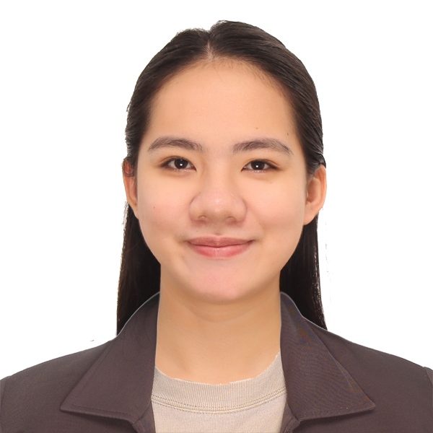
Jessa Mae Famoso
brgy. tampalon, kabankalan city, negros occidental, philippines 6111
+63977 036 0508 ▪ famosojessa07@gmail.com

Experiences

Objectives
----------------------------------

Obtain a position in a technical retrospect that would challenge and develop skills and bring out the best of my potential in taking part into the success of the organization and the company as they thrive for market domination and customer satisfaction.

Skills
-------------------------------
○ Can communicate in English effectively both written and verbal
○ MS Office Proficient (Word, Excel, PowerPoint, Outlook)
○ Acquainted with Laboratory Analysis Principles
○ Customer-oriented and has fundamentals of sales routine
○ Goal-oriented and result-driven

Sales Account Executive
Nagase Philippines International Services Corporation
Salcedo Tower, 169 H.V. Dela Costa St. Salcedo Village Makati City, PH
June 2020 – present

- Managing accounts by attending to the needs and providing support for continuous production and assembly of customer
- Controls inventory by assessing the purchasing and ordering plan for seamless delivery to customer. Ensuring stock availability by coordination with warehouse team and supplier.
- Sales and marketing of plastic resin, chemicals, and automotive components for Japanese and non-Japanese customer under Mobility Division.
- Reviews technical data and information of various plastic resin and chemicals prior importation
- Assist existing customers with RoHS and IMDS-related request. Ensuring environmental compliance for all materials supplier
- Knowledgeable about PEZA requirements as part of the business transaction such as LOA Application
- Develops new business by communicating with Automotive OEMs

Sales Executive
Vistachem Southeast Asia Inc.
2005 20F Strata 100, Ortigas Center, Pasig City, Philippines
July 2019 – January 2020

- Acquainted with different raw materials for manufacturing industries (e.g. petrochemical, paint and coatings, plastics and polymer, welding consumables, pharmaceutical, food, etc.)
- Establish harmonious client-supplier relationship for continuous business partnership
- Has brief background on product registration under government agencies such as FDA, DENR, etc.
- Sources out all sorts of chemicals and raw materials from different countries of origin
- Creates business report and database regarding sales progress

Personal Information
----------------------------------

Age : 22
Date of Birth : 11-04-98
Citizenship : Filipino
Gender : Female
Civil Status : Single
Height : 158 cm
Weight : 50 kg.

Character References
-------------------------------
Fritzie B. Asuncion
Department-in-Charge
Technological University of the Philippines – Visayas
+639 09 180 1342

Jewel Sario
Chief Sales Representative
Vistachem Southeast Asia Inc.
+639 17 817 5458

Masahide Kuge
Sr. Sales Manager
Nagase Philippines
+639 17 117 8324

Laboratory Technician at Materials Science Laboratory
Western Digital Philippines
Laguna Technopark, Biñan, Laguna, Philippines
November 2018 - June 2019

- Performs Qualitative and Quantitative Analysis
- Able to prepare laboratory solutions for laboratory analysis
- Conducts Physical Characterization and Chemical Characterization of finished goods
- Certified to operate Scanning Electron Microscope- Energy Dispersive Spectroscopy used to ensure cleanliness of finished goods

OJT (Quality Control Analyst) at Supply Chain
Ecolab Philippines Inc.
Laguna Technopark, Biñan, Laguna, Philippines
January 2018 - June 2018

OJT at Sugar and Renewable Division
Universal Robina Corporation- Sonedco
Brgy. Camugao, Kabankalan City, Negros Occidental, Philippines
April 2016 - May2016 and April 2017 - May 2017

Educational Background
Tertiary Chemical Engineering Technology
Technological University of the Philippines-Visayas
Capt. Sabi St., Talisay City, Negros Occidental

Secondary Fellowship Baptist College
Rizal St., Kabankalan City, Negros Occidental
Second Honorable Mention

Elementary Tampalon Elementary School
Brgy. Tampalon, Kabankalan City, Negros Occidental
Valedictorian

Seminars and Awards

Professional Regulation Commission Licensed Chemical Technician (Registration No: 0003233)

Outstanding Technician Award / Dean’s List (Academic year 2015-2016)

