

RAYMUND L. VALERIO

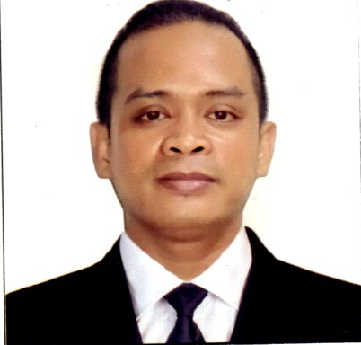
CAREER OBJECTIVE

Seeking a job as a housekeeper, using my organizational skills
and cleaning experience to maintain a well-groomed and orderly home.

EXPERIENCE

Tropical Hut Food Market Computer Technician
March 2002 to September 2002

Jollibee EAC Taft
Kitchen Staff
January 2003 to June 2003

Jollibee U.N. Times Plaza
Kitchen Staff
June 2003 to December 2003

Jollibee Harizon
09369773319
Kitchen Staff
January 2004 to June 2004

Jollibee PRC
Kitchen Staff
July 2004 to July 2006

Jollibee Waltermart Makati
Kitchen Staff
August 2006 to March 2007

Corian Corporation
Helper
January 2008 to December 2012

MJM Globakits Corporation
Inistaller/Leadman
January 2009 to December 2012

Luxent Hotel
Housekeeping
January 15, 2013 to March 12, 2018

Go Hotel
Housekeeping
May 14 up to present

SEMINARS AND AWARDS

Certificate of Completion

Delighting Customers… the luxent way

August 8, 2013 at Luxent Hotel

Work and Attitude Values Enhancement Seminar (WAVES)

July 29, 2016 at the Conference A & B of Luxent Hotel, Q. C. Phils.

Effective Customer Service With Image Enhancement

August 17, 2016 at VIP 2 of Luxent Hotel, Q.C. Phils.

Housekeeper of the Month

June 14, 2014 at Luxent Hotel

EDUCATIONAL ATTAINMENT
Datamex Computer Institute
Computer Technician

Araullo High School
1997 - 2001

Rafael Palma Elementary School
1991 - 1997

SPECIAL SKILLS

Playing Basketball and Driving Motorcycle

ADDITIONAL INFORMATION

Provincial Address : Pangasinan City Height : 5’3”

Sex : Male Weight : 62 kg.

Date of Birth : March 6, 1984 Father’s Name : Luis B. Valerio

Place of Birth : Manila Occupation : Carpenter

Civil Status : Married Mother’s Name : : Luisa L. Valerio

Nationality : Filipino Occupation : Housewife

Religion : Roman Catholic Their Address : #2416 Oro-B St., Sta.

Laguage Spoken : English / Tagalog Ana, Manila

CHARACTER REFERENCE

Mark Alfred D. Tiosen

Account Resolution Specialist 4

Wells Fargo

09176510035

Richard L. Valerio
Branch Manager
Westrade International Ortigas
09324545387

I hereby certify that the above information is true and correct to the best of my knowledge
and belief

___________________________
Raymund L. Valerio
Applicant

