JOSE LUCARIZA SALVE Jr.
Prk Sto.Nino, Brgy. Handumanan
Bacolod City
Contact # +63 910 981 2291
E-Mail Add: Wade_jose18@yahoo.com
Passport # P3690704B
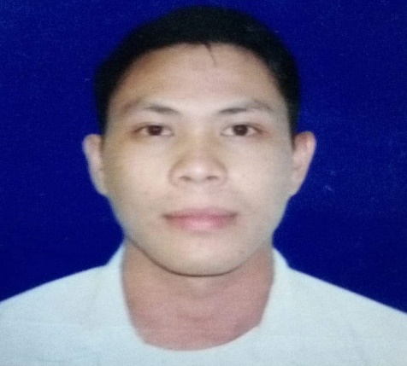

Objective:

To seek for opportunities and to have a challenging and responsible position that I could apply my education and enhance my skills and abilities to become a productive and competitive individual.

Work Experience(s):

August 2018 - Present
Bus Conductor • JAC Liner

November 2014 – July 2019
Bus Conductor • Vallacar Transit Inc

February 2013 – June 2014
Merchandiser• Lamont Corp.

October 2010 – June 2012
Merchandiser• Maria Corp.

August 2007 – February 2008
Service Crew • Jollibee

Educational Qualification(s):

Asian Collage of Aeronautics (2010)
- Graduate with Maintenance Technology Course
Mansilingan Agro-Industrial High School, Bacolod City (2004)
- Graduated in High School
Antonio L. Jayme Elementary School, Bacolod City (2000)
- Graduated in Elementary

Personal Information:
Born October 8, 1986 at Bacolod City by Veronica Lucariza Salve and Jose P. Salve Sr. who were both members of Iglesia Ni Kristo. Married to Rosefer Legaspi Salve and a father of two loving kids. Has proficiency in English and Filipino Language.

Skill(s) and other Qualification(s):

• Customer Service
• Proficiency in Microsoft Office (eg. Word, Excel and Powerpoint)
• Personnel Administration
• Communication
• Workload

References

• Mr. Rene Quezon
Branch Manager, Honda Motors. – Bacolod City
Mobile No(s): 09235142977

• Mr. Kenneth Celiz
Sales Manager, Pepsi Company – Bacolod City
Mobile No(s): 09989880224

