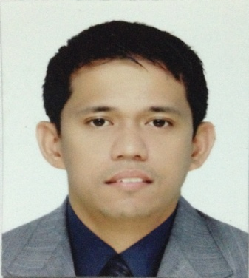
Clent Naval Coprado
1832 MaharlikaSt. Tondo, Manila
Mobile #: 09662706826 / 09193573306
E-mail Address: clentcoprado@yahoo.com

OBJECTIVE:

To utilize all the skills, knowledge and learnings that I have acquired during my long
time experience as a service provider and also to contribute and exercise all the capabilities that I possess in order to be the best asset in a reputable company.

EMPLOYMENT HISTORY:

Position: Junior Stateroom Steward
Company: C. F. Sharp Crew Management Inc.
Address: Casa Rocha Gen. Luna St.Intramuros, Manila
Date: December 2017 – May 2018

Position: Cabin Steward
Company: Magsaysay Maritime Corporation
Address: T.M Kalaw St. Ermita Manila
Date: August 2016 – June 2017

Position: Cabin Steward
Company: North Sea Marine Services
Address: 1535 M. Adriatico St. Ermita Manila
Date: June 2014 –November 2015

Position: Cabin Steward
Company: Five Star Marine Services Corporation
Address: 964 Escodacor. San Marcelino St. Ermita Manila
Date: September 2012 – April 2014

Position: Cabin Steward
Company: Able Maritime Services
Address: Ground Flr. Cynros Bldg. 513 Alonzo St. Malate, Manila
Date: June 2010 – October 2010

Position: Housekeeping Cleaner
Company: North Sea Marine Services
Address: 1535 M. Adriatico St. Ermita Manila
Date: June 2008 – January 2009

Position: Housekeeping Cleaner
Company: Magsaysay Shipping Company
Address: T.M Kalaw St. Ermita Manila
Date: December 2002 – December 2007

Position: Room Attendant
Company: Sofitel Philippine Plaza (formerly Westin Philippine Plaza)
Address: CCP Complex Pasay City
Date: May 2002 – November 2007

Position: Room Attendant
Company: Ascott Makati (formerly Oakwood Premier Hotel)
Address: Glorietta Ayala, Makati City
Date: October 2001 – April 2002

Position: Room Attendant
Company: New World Renaissance Hotel
Address: Makati City
Date: February 2001 – August 2001

SEMINAR/TRAINING/S ATTENDED:

Hotel and Restaurant Services
Manila Manpower Development Center
Arroceros St. Manila
June 30, 2009 to July 30, 2009

Basic Customer Service Course for F&B Staff
Pier 4 North Harbor Training Room
Pier 4 North Harbor Manila
March 16 – 17, 1999

Hygiene and Sanitation
Bureau of Quarantine Office
25th St. cor A.C Delgado St. Port Area Manila
February 11 – 12, 1999

SKILLS AND INTEREST:

- Basic coffee preparation and serving.
- Skilled in food preparation of different assigned a la carte dishes.
- Well versed in oral and writing English and Filipino.

PERSONAL DATA:

Address: 1832 Maharlika St. Tondo, Manila
Birth date: September 17, 1976
Birthplace: Sta. Rita Hospital Balot, Tondo Manila
Height: 5’8
Weight: 145 lbs.
Age: 42
Sex: Male
Civil Status: Married
Religion: Catholic

EDUCATIONAL BACKGROUND:

Tertiary : Aklan Polytechnic College
Bachelor of Science in Marine Engineering
Quezon Ave. Kalibo, Aklan
1993 – 1996

CHARACTER REFERENCES:

- Mr. Hernani N. Aga
Ret. Police Officer
Manila Police District
Mobile No: 09053119195 / 09322445859

- Mr. JericoTungcab
Master Mariner Captain
Knutsen OAS Shipping
Mobile No: 0927 568 83460

- Mr. Jason Decena
Crewing Manager (Optimum Shipping Company)
Magsaysay Maritime Shipping Company
Landline No: 526 8888

