JOHN DOMINIC A. MACASIEB 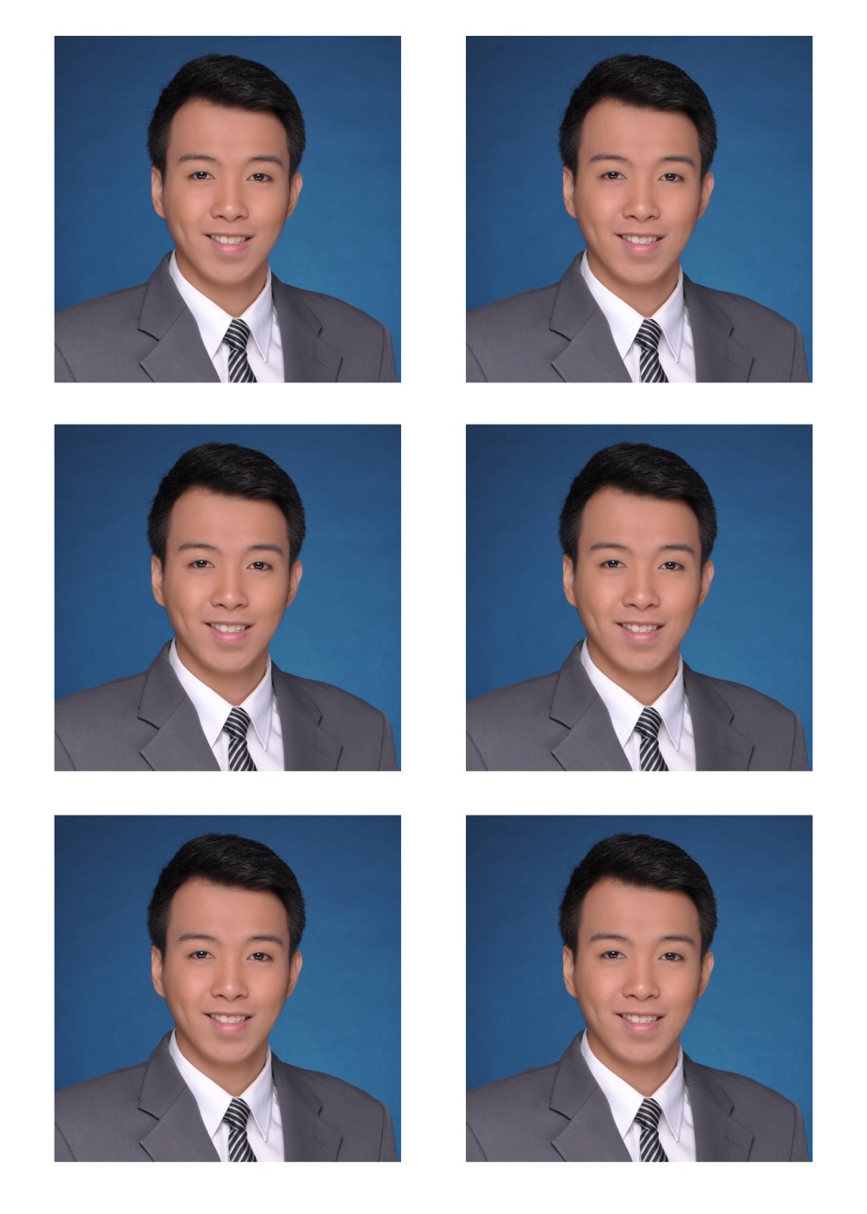

20 J. Lopez de Leon St. Greenheights Subdivision, San Isidro, Parañaque City
macasiebjohndominic@yahoo.com.ph
(+63917) 524-3394

OBJECTIVE

To apply for a job to apply all acquired knowledge and skills in the performance of actual operations in the field of Airline industry.

EDUCATION

2008-2012 UNIVERSITY OF SANTO TOMAS
Bachelor of Science, Major in Tourism

1998-2008 ST. ANDREWS SCHOOL OF PARANAQUE
Grade School Diploma, 2004. High School Diploma, 2008

ACHIEVEMENTS

- 1st Place, Diocese of Parañaque Private Schools Association Basketball Tournament, Member, Varsity Team 2007
- Member, Top 25 Academic Performers in Batch, St. Andrews School Commencement Exercises, 2008
- Recipient, Pres. Gloria Macapagal-Arroyo Award for Culture and Arts, St. Andrews School Commencement Exercises 2008

QUALIFICATIONS & SKILLS

- Fluent in English.
- Strong sense of leadership and team-oriented mind-set.
- Strong oral and written communication skills.
- Proficient in Microsoft Office.
- Knowledgeable in Philippine Civil Aviation Regulations (Flight and duty limitations)
- Knowledgeable in European Aviation Safety Agency flight time limitations
- Proficient in Aviation Management Resource System V2 (ARMS V2.)
- Proficient in Airline Information Management System (AIMS.)
- Private Pilot License Holder (SEL)

AFFILIATIONS

- Treasurer, Students Tourism Society, University of Santo Tomas 2009-2011
- Auditor, Students Tourism Society, University of Santo Tomas 2011-2012
- Officer-in-Charge, Physical Arrangement and Technical Support Committee, Students Tourism Society, University of Santo Tomas 2010-2012
- Committee Head, Physical Arrangement and Technical Support Committee, Turimasino: Continuing the Legacy of Thomasian Pride, 3T4 Events Management
- Member, Organizing Committee, The Search for Ideal Thomasian-CTHM Personality 2010
- Member, Flight Safety Action Group, Cebu Pacific Air, 2018
- Member, Occupational Safety Hazard Committee, Cebu Pacific Air, 2019

SEMINARS/LECTURES ATTENDED

- Operations Controllers Emergency Response Training (Blake Emergency Services)
Cebu Pacific Airline Operations Center, Domestic Road, Pasay City
05 September 2015

- Lecture on Fatigue Management
Cebu Pacific Airline Operations Center, Domestic Road, Pasay City
07 January 2016

- SAFE User Gathering 2019
Grand Copthorne Hotel, Singapore
06 March, 2019

- Fatigue Risk Managment System (IATA)
Malaysia Airlines Academy, No. 2 Jalan SS7/13 Kelana Jaya, Selangor Darul Ehsan, Malaysia
04-06 December, 2019

WORK EXPERIENCE

- Allpoints Travel Services, Inc. – UST Satellite Office, 1/F Albertus Magnus Building, UST, España, Manila (November 2011 – March 2012)

  - Staff for Operations (Practicum Trainee)
    - Responsible for the operations (ticketing, receive payments and logistics) of the travel agency.
    - In the course of our training, the practicum training team produced a smooth flow of operation, high number of tour participants and reduced loss of revenue in comparison with previous practicum training groups.
    - our team,

- Cebu Pacific Air – 8006 Airline Operations Center, Domestic Road, Pasay City

  - Assistant Crew Controller (Crewing Department)
September 2012 – February 2015
    - Maintains the daily schedule of the crew for the flights and ensures every flight for the day is manned.
    - Ensures flight documents are properly generated and endorsed to the operating crew.
    - Applies the changes given to the schedule to ensure the smooth flow of operations on a daily basis.

  - Assistant Crew Planner – Long Haul (Crew Scheduling Dept.)
January 2016 – October 2020
    - Ensures the efficient planning of the monthly rosters of the crew for long-haul operations.
    - Plans and maintains the flight training schedule and line training schedule.
  - Supervisor - Crew Control (Crew Scheduling Dept.)
October 2020 – Present
    - Oversees and maintains the daily schedule of the crew for the flights and ensures every flight for the day is manned.
    - Ensures flight documents are properly generated and endorsed to the operating crew.
    - Applies the changes given to the schedule to ensure the smooth flow of operations on a daily basis.

PERSONAL INFORMATION

Nickname: Jonic
Status: Married
Gender: Male
Nationality: Filipino
Age: 30 years old
Birth date: March 12, 1991
Religion: Roman Catholic
Height: 5’10’’
Weight: 192 lbs.

CHARACTER REFERENCE

Mr. Jonathan Carl Sims
Head – Crew Scheduling Department
Cebu Air, Inc. (Cebu Pacific Airlines)
JonathanCarl.Sims@cebupacificair.com

Ms. Katrina Mari B. Flores
Manager – Crew Scheduling Department
Cebu Air, Inc. (Cebu Pacific Airlines)
KatrinaMari.Flores@cebupacificair.com

