HAROLD SHERRIS A. CUA
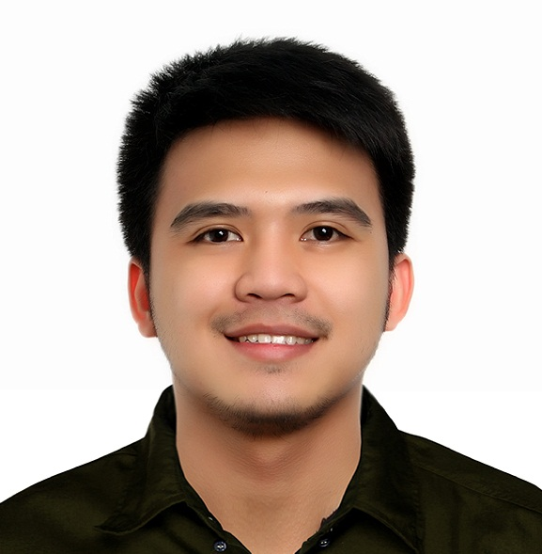

2 x 2 picture
BS Environmental and Sanitary Engineering

Address: #233 Concepcion St. Santolan, Pasig City
Email Address: haroldcua001@gmail.com
Cellular No.: 09755636936

OBJECTIVE

To establish a career in engineering where I can demonstrate the learning outcomes of the Environmental and Sanitary Engineering program of the Technological Institute of the Philippines, a program accredited by the US-based outcomes-oriented ABET (Accreditation Board for Engineering and Technology), Engineering Accreditation Commission.

DESIGN PROJECTOJECTS COMPLETED/ RESEARCH/ES UNDERTAKEN

- Prefabricated Prefinished Volumetric Construction (PPVC) UNIT for Midrise building 2021
- Storm Water, Sewerage and Drainage Design System Analysis

Offers proper guidance on the planning, design, importance of drainage system/ drainage works together with the proper design computation of water distribution needed to accommodate people in the controlled area.

- Plumbing design of 5 storey building
- Analyzing the cost of bill materials used in a whole construction project.
- Including Sewage, Water Supply and Septic tank.

EDUCATIONAL BACKGROUND

Tertiary | Technological Institute of the Philippines (TIP), Quezon City
Secondary | Santolan High School Marisol Subd., Santolan Pasig City
Primary | Santolan Elementary School Evangelista St. Santolan Pasig City
ON-THE-JOB TRAINING/ PRACTICUM/ INTERNSHIP EXPERIENCE/S

- Manila Water Company, Inc.
MWSS Administration Building 489 Katipunan Road, Balara, Quezon City 1105
(ENGINEERING DEPARTMENT)
KNOWLEDGE, SKILLS AND ATTITUDE

Having taking course from TIP with its orientation towards outcome-based education, I have acquired and can demonstrate the following student acquired outcomes (knowledge, skills and attitudes) necessary to the practice of the engineering profession:
- Use modern techniques, skills and tools of the engineering practice in complex computing activities.
- Analyze complex problems and identify and define the engineering requirements appropriate for solutions.

JOB EXPIRIENCE

- FIELD ENGINEER (MEFPS)
JUNE 2019 – Present
Makati Development corp. (MDC)
- QA/QC ENGINEER
Feb 2017- Feb 2019
(FDPY Pipe Specialist Co.)

- January – march 2016 Manila Water Company, INC. Internship complete
SEMINARS AND TRAINGS ATTENDED
- February 2016 Site Visit: EMB Central Laboratory and EMB NCR Air Quality Monitoring Equipments.
- September 2014 Dare to Face the Problems in Solid Waste, TIP-QC
- September 2014 Smart Sanitation: Water and Waste Water Technology
- September 2014 Technology on Water Treatment: Sustainable Water-Environment Needs, TIP QC
- Feb 2014 Technology on Water Treatment: the Forefront of Environmental Protection.
EXTRA AND CO-CURRICULAR ENGAGEMENTS AND VOLUNTEER WORKS

- PSSE Member, Quezon City) – September 19, 2015
- (DENR-EMB) Adopt-An-Estero/Coastal Clean Up Drive (Valenzuela City)– September 26, 2015

OTHER SKILLS

- Basic knowledge in designing Water Supply System and Sewerage System
- Designing of Sanitary and Plumbing System
- Proficient in Microsoft Office (Word, Excel, and Power Point)
- Knowledgeable in AutoCAD
- Can speak English and Tagalog
.
REFERENCES

Marlene Dollesin
Architect, MDC
09362784856

Engr. Alvin Santos
MEFPS Super Visor, MDC
09155349795

