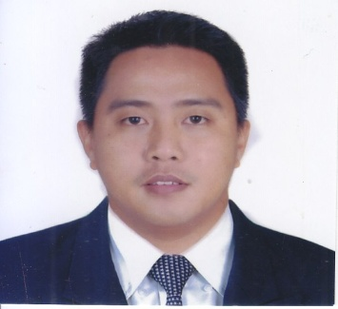
s
Tagalog
English
Arabic

LANGUAGES
MS Word
Excel
PowerPoint
Outlook
Tally ERP9
SOFTWARE
Computer Installation
Hardware
Software
Trouble Shooting
Networking

Nov 2005 -
March 2006

ON THE JOB TRAINING
720 hours
SILICON VALLEY COMPUTER SCIENCE CENTER
TESDA
THERAPEUTIC MASSAGE
10 days
September 2012

ISO 9001: 2015 AWARENESS TRAINING
Feb 2019

ACT MASTER
Feb 2018 -
April 2018

ARABIC
18 hours
FILIPINO TRAINING & DEVELOPMENT CENTER
March 2019 -
May 2019

MASSAGE THERAPY
36 hours
CAREGIVING 1, 2, 3 & 4
72 hours
Nov 2018 -
May 2019
PHILIPPINE INTEGRATED INSTITUTE QATER
TRAINING
ELEMENTARY
1991 - 1997
ODELCO ELEMENTARY SCHOOL
Class of 1997
HIGH SCHOOL
1997 - 2001
SAN BARTOLOME HIGH SCHOOL
Class of 2001
UNIVERSITY
2003 - 2006
QUEZON CITY POLYTECHNIC UNIVERSITY
Computer Technician Diploma
EDUCATION
PC GILMORE COMPUTER CENTER
Product Specialist / Computer Technician
April 2006 to
August 2010
NORTHSTAR 7 PREMIUM INTERNET CAFE
Computer Technician
Sep. 2010 to
March 2013
April 2013 to
March 2014
ROWELL LITHOGRAPHY & METAL CLOSURE
Operator
April 2014 to
October 2014
PINAKAMASARAP CORPORATION
Checker
PHILIPPINES
LOGIC INFORMATION TECHNOLOGY
Product Specialist / Computer Technician / Accountant
March 2015
to present
QATAR
WORK EXPERIENCE
Highly focused and detail-oriented individual with an exceptional record for client service. Able to manage multiple projects with high efficiency and accuracy. Highly motivated and capable at working independently or as a team. With 2 year working experience in the retail-fashion industry.
ROBERT SANYES CU
SKILLS
ADDRESS:
Villa 47 Zone 43 St 720, Al Mamoura,
Doha, Qatar
EMAIL:
robertsaynescu1984@gmail.com
MOBILE:
+974 5545 8650
DATE OF BIRTH:
April 25, 1984
NATIONALITY:
Filipino
PERSONAL INFORMATION

