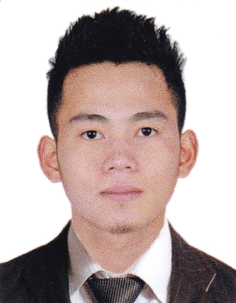
De JESUS, mIKE kEVIN, b.
Rhapsody Residences, Parañaque City
0945-514-6236
mikevindejesus@gmail.com
Objective
To share my skills, professional ideas and be a part of an organization that will allow me to develop my potentials both professionally and personally. To be in a position that would encourage a long term commitment conducive to professional growth and achievements.

Professional Experiences
- Worked as a Freelance Real Estate Agent (Early 2019)
- Worked as on-site Practice Construction Engineer (Early 2018)
- Worked onboard overseas as Deck Cadet from 2012 – 2014
- Worked onboard overseas as Ordinary Seaman from 2014 – 2016
- Worked onboard overseas as Able-bodied Seaman from 2017-2018
- Worked as a Marketing Executive on a lending company (2019 – January 2020)

Educational Background
High School
San Beda College Alabang 2005-2009

Bachelor of Science in Marine Transportation
Asian Institute of Maritime Studies 2009- 2012

Names of Previous Employers
- Manila Shipmanagement & Manning, Inc.
- West Coast Lines & Transport, Inc.
- NAESS Shipping Philippines, Inc.
- Metro Quicash lending corp.

Skills
- Proficiency in Filipino and English
- Microsoft Word
- Microsoft Excel
- Web Research
- Capable to Self-Study
- Can work under pressure
- Good Listener

Character Reference:

Mr. Armin Cariño
Manila Ship Management inc.
0917-550-1294

