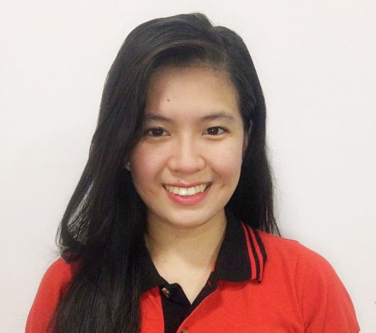 |  |  |  |  |  | CHARISSA MARIE T. ACOSTA  - HR-SENIOR OFFICER  Objective  - Secure a responsible career opportunity to fully utilize my training and skills, while making a significant contribution to the success of the company.  Experience  HR-Assistant manager  August 2019 up to present  - Assist with day to day operations of the HR functions and duties  - Provide clerical and administrative support to Human Resources executives  - Compile and update employee records (hard and soft copies)  - Process documentation and prepare reports relating to personnel activities (staffing, recruitment, training, grievances, performance evaluations etc.)  - Coordinate HR projects (meetings, training, surveys etc.) and take minutes  - Deal with employee requests regarding human resources issues, rules, and regulations  - Assist in payroll preparation by providing relevant data (absences, bonus, leaves, etc.)  - Communicate with public services when necessary  - Properly handle complaints and grievance procedures  - Coordinate communication with candidates and schedule interviews  - Conduct initial orientation to newly hired employees  general admin  October 2012 – December 2017  - Do timekeeping and attendance monitoring  - Do weekly. Monthly and yearly manpower report submitted to the company president  - Handled petty cash of HR Department  - Do reimbursement reports of HR dept submitted to Finance dept.  - In-charge in processing of business permit  - In-charge in 5s audit  - In-charge in issuance of purchase orders to suppliers  - In-charge in outsourcing of possible suppliers
 | C O N T A C T
 |  | charissacosta27@gmail.com
 |  | 0977-481-3661
Laguna City,
Philippines

 |  | E D u c a t i o n
 |  | paradigm colleges of  Computer Hardware Servicing NCII  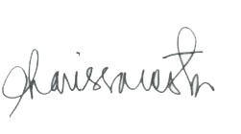  2009-2011



