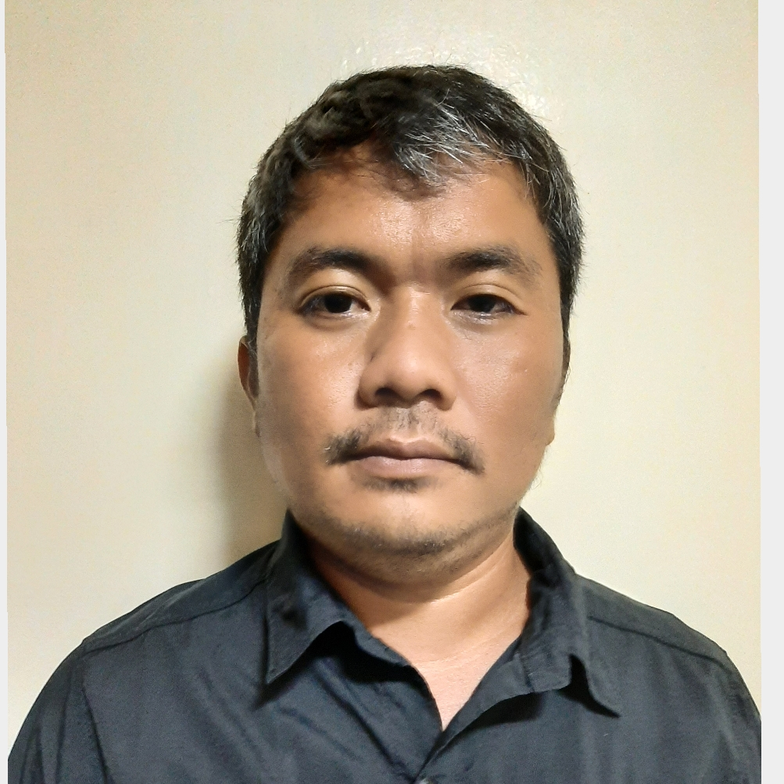 |  |  |  | EUGENE SALE  DAIGDIGAN

I am a professional with 10 years of experience in pineapple business industry. Aiming to further explore the Agriculture business world for added knowledge and self-value. Not only experienced in pineapple growing, out grower program and harvesting for fresh and cannery, but also have knowledge in packing operations as well as dealing with pineapple fresh markets. Quality and customer focused and has a strong drive for results.

Work Experience
2017 TO PRESENT

HARVESTING OPERATIONS MANAGER

Manages pineapple harvest operations for both fresh and cannery fruit at a maximum capacity of 2500 metric tons for cannery including IQF (Individually Quick Frozen) and 60,000 fresh fruit boxes on a daily basis. Effectively managed over a thousand workers composed of management staff, regular hourlies and those under service providers. Leads in daily harvest operation and equipment planning as well as mid and short range tonnage, boxes estimate and involved in fresh market negotiations. Ensures effective coordination and collaboration between fresh packing plant and cannery for smooth and cost effective operation while also putting quality on top.

2014 to 2017

Growership and Expansion Operations Superintendent, DOLE PHILIPPINES INC.
A farm owner, manages more or less 3,000 hectares of pineapple plantation under growership and managed program from canvassed land approvals, land preparation, planting, field maintenance, fruit care and harvesting. Responsible for yield performance of assigned area of responsibility as well managed company facilities in expansion areas. Acquired valuable knowledge in community relations and pineapple growing economics, resource allocation and planning as well developed and enhanced leadership skills.

July 2011-2014

Harvest Operation Supervisor, DOLE PHILIPPINES INC.

Manages pineapple Harvesting operations for both fresh and cannery fruit including delivery commitments for both packing plant, cannery and IQF (Individually Quick Frozen) with the goal of delivering committed volume with the best quality while optimizing fresh and cannery operations. Minimizes downtime and being cost effective through good coordination.

2010-2011 Agri-Technical Surveyor, LAPANDAY DIVERSIFIED PRODUCTS CORPORATION Aglayan Malaybalay City, Philippines

Conducts field survey on plant population, pest and disease, one time bud count, plant height and weight, heart cutting, fruit estimating and sucker survey for pineapple.

2001-2002 Labor Helper, JCGC Agency-GEORGIA FUENTES Bugo Cagayan de Oro, Philippines

Labor helper on Pineapple Cannery Seamer-Filler Machine Overhauling.

Education

OCTOBER 2007

Bachelor of Science in agriculture, xavier university ateneo de cagayan

References
[Available upon request.]
BLK 10 LOT 24 PCH 2
SAN MIGUEL, MANOLO
FORTICH, BUKIDNON 8703

 |  | 0963-596-4843
 |  | eugenedaigdigan28@  gmail.com
 |  | [Your Website]

