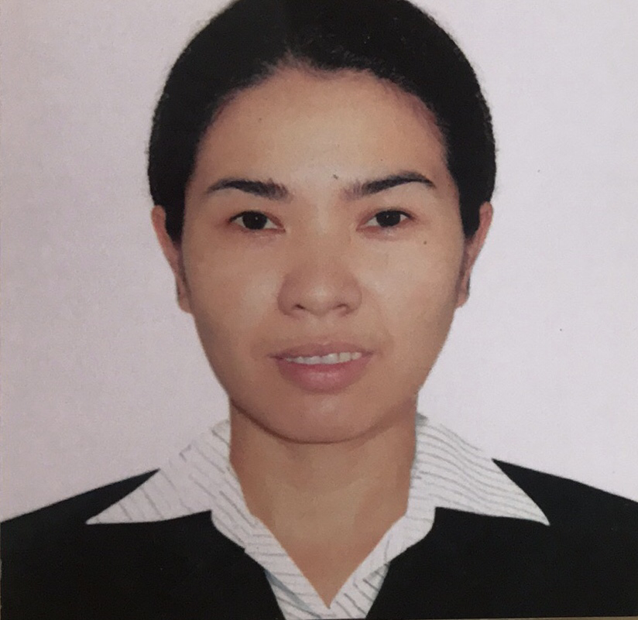
RENGEL D. VETCHO
Mahayahay Bankal Lapu-Lapu City, Cebu
09288155901
rengeldeclaro@gmail.com
PERSONAL INFORMATION
Date of birth : March 14, 1980
Age : 41
Place of birth : Bien Unido Bohol
Nationality : Filipino
Gender : Female

EDUCATIONAL BACKGROUND

Secondary : Tipolo National High School
Tipolo Mandaue City, Cebu - Batch 1993-1997
Elementary : Bien Unido Elementary School
Bien Unido Bohol - Batch 1987-199
WORKING EXPERIENCE

Sigurd Microelectronics Inc.
Hsinchu, Taiwan
Production Operator
December 2014- April 2021

ACTC Tera Xtal Inc.
Hsinchu, Taiwan
Production Operator
August 2013- August 2014

Gigabyte Technology Inc.
Taoyuan, Taiwan
Production Operator
August 2009- August 2012

Farming
Bantayan , Cebu
Helping Cormfield in Provice
2008-2009

Taiyo Yuden Phil. Inc.
Lapu-lapu City Cebu Philippines
Quality Assurance Inspector
Quality Assurance Engineer Assistant
July 2000 – March 2008

