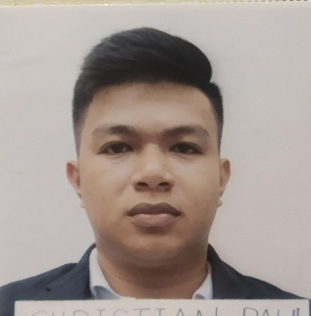
CHRISTIAN PAUL V. LAUREANO
Block 11 Brgy. Sinikway Lapuz, Iloilo City / 09460908999 / laureanoc13@yahoo.com

Summary
Skilled Welder with proficiency in SMAW, drill press and metal fabrication. Specialise in using stick weld. Capable of reading and interpreting drawings and diagrams.
Highlights
- Expert in stick welding
- Pipe welding
- Basic automotive
- Basic lathe machine
Experience
Garbage Utility
Dec. 27, 2018 – Sept. 10, 2019
Nov. 4, 2019 – July 3, 2020
April 30, 2021 – Present
SEABOURN CRUISE LINE LIMITED – SEATTLE, WA 98119

- Proper segregation of garbage.
- Cleaning and maintaining the machines.
- Using proper PPE before operation.
- Followed all the procedures and guidelines for safety .
- Repairing machines according to its own manual.

Welder/Fitter June 2015 – January 17, 2017
JBU MARINE WORKS AND SERVICES – Iloilo City, Philippines

- Respond to service calls quickly and professionally.
- Set up equipment and weld parts according to welding chart specifications and type.
- Inspect grooves ,angles and gap allowances with micrometre, calliper and other precision instruments.
- Laid out, fitted and fabricated metal components.
- Monitored the fitting, burning and welding processes to avoid overheating parts, warping, shrinking, distortion and expansion of materials.
- Followed all the safety guidelines, including proper machine guarding and lockout and tagout procedures
Education
- SHIELDED METAL ARC WELDING NC II May 18, 2015
TESDA – RTC 6 - Iloilo city, Philippines
- LATHE MACHINE OPERATOR January 23, 2017 ILOILO SCIENCE AND TECHNOLOGY UNIVERSITY – Iloilo City, Philippines
- ENGINE TUNE-UP March 14, 2017
ILOILO SCIENCE AND TECHNOLOGY UNIVERSITY – Iloilo City, Philippines
- SHIP’S CATERING SERVICES NC I April 18, 2018
Ship Hotel Cruise Institute of the Phil’s., Inc - Makati City, Philippines

