Curriculum Vitae

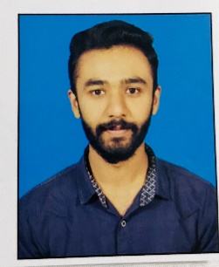
Shahzaib Khan

Cell No: 0342-1624738
Whatsapp: +923421624738
E-mail: sk0109495@gmail.com
Address: Jia Musa Fazlan Street Near S.I.L School Shahdra Mor Lahore

Objective:

To achieve a challenging position with opportunities for increasing responsibilities and professional growth in a reputed organization where I can utilize my personal abilities &
Professional skills effectively.

Personal Information:

- Father Name: M.Shafaqat Ali Khan
- C.N.I.C: 35202-7220503-7
- Date Of Birth: 28-9-1998
- Religion: Islam
- Nationality: Pakistani
- Domicile: Lahore
- Marital Status: Single

Qualification:

Degree | Session | Board
B.A | 2020 | Punjab University
F.A | 2018 | BISE LHR
Matric | 2015 | BISE LHR
Computer Hardware Network Professional | 2019 | Vocational Training Institute

Computer Skills:

- IT Hardware Basics:
- Microsoft Office 2007
- Network Professional.
- Application software.
Language;
- Urdu
- English
- Punjabi
Reference:
Reference will be furnished on demand.

