Experience
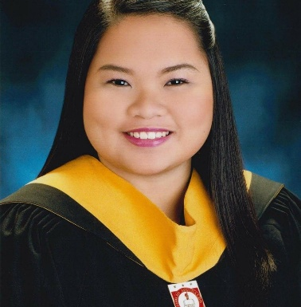

jazzmin joy s. jubinal

Objective
Aiming to work in an environment that will help me achieve in pursuing my aspiration in the HR field. Aspiring to be hired in a position that will further enhance my intellectual and interpersonal skill, considering the dedication, years of work experience and the on-going exposure in the administrative and recruitment side in the field.

contact

 jazzjubinal@gmail.com

+63 926 448 2742

Ph3 Bllk 92 Lot 6 Bayabas Street, Mary Cris Complex, Pasong Camachille 2, General Trias, Cavite

RS CARSON GENERAL CONSTRUCTION CORPORATION

HR STAFF/ASSISTANT RECRUITER

JULY 2019 – present
- Assists in the company’s recruiting process of workers including contacting potential candidates, scheduling interviews, following up during the recruitment process, and updating employee records. Also performs background checks and verify a candidate’s qualifications and experience.
- Administrative work, such as but not limited to encoding of newly hired employees, sorting and filing of 201 for both staff and workers, preparing report for tardiness per month and manpower headcount for sites.

WORLDLINK RECRUITMENT AND PLACEMENT SERVICES INC.

HR RECRUITMENT ASSOCIATE

APRIL – JULY 2019

EMILIO AGUINALDO COLLEGE – MANILA

REGISTRAR CLERK/EVALUATOR

AUGUST 2016 – MARCH 2019

Education
Bachelor of Science in Business Management major in human resource development management
emilio aguinaldo college – cavite, city of dasmariñas cavite

april 2016

key skills and characteristics
Strong interpersonal & communication skills • MS Office Suite • Ability to work collaboratively as part of a team • Ability to deal with different type of personality • Meticulous attention to detail • Can perform well with all tasks given • Poised under pressure

