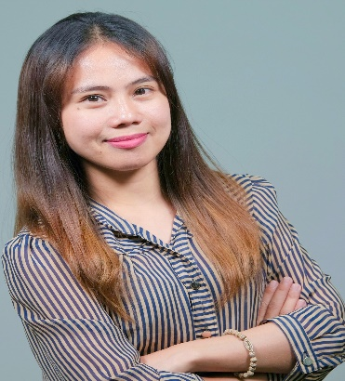

Personal Info:

Age: 29

Nickname: “je”

Date of Birth: Jan. 17, 1992

Place of Birth: Salcedo E. Samar

Gender: Female

Civil Status: Single

Nationality: Filipino

Religion: Roman Catholic

Degree Finished: BS in Computer
Engineering

Languages:

◊ English
◊ Filipino
◊ Basic Japanese
◊ Bisaya
◊ Waray-Waray

References:

Ms. Corazon Pomarca
FiberHome, Manila
09287222755

Mrs. Jill Armamento
Global Reporting
Subject Matter Expert
Lexmark R&D Cebu City
09088624360

Mrs. Hanna Pelago
Data Analyst
Lexmark R&D Cebu City
09199422821

JEANETTE CABALLEGAN MENDOZA
Ramos Street, Cebu City 6000
09991079620
jeanettemendoza075@gmail.com
jeanette.mendoza26@yahoo.com

Career Highlights:

- Providing Global Monthly Operational Reports
- Customizing reports requested by the customer.
- Creating/ Scheduling Calendar
- Providing data analysis
- Data Evaluation and Validation
- Field and Admin Assistant
- Assisting Livelihood and Shelter Project provided by ICRC
- Assisting Maternal and Neonatal Health care survey
- Basic Troubleshooting skill

Technical Skills:

- Microsoft Excel
- Microsoft Power Point
- Microsoft Word
- Analytics
- Siebel
- SAP
- Power BI
- Basic AutoCAD/Photoshop
- Basic PC Troubleshooting

Personal Skills:

- Communication
- Highly organized and efficient
- Ability to work independently or as part of a team.
- Time management
- Ability to work under pressure

Work Experience:

Duration: July 2016 – Present
Company: Lexmark R&D Cebu City
Position: Global Reporting Specialist
Job Responsibilities: Creating a monthly summary report (MOS) on the printer status for each handled account. Reports contains the invoice data, number of fleets/devices, service details (FCC, service calls) and other data files needed to create the MOS. Report show those printers that are going to expire as well as for those that are recently installed. Part of my job also are modifying and customizing the report, depends on how the costumer would like to see the content of the report. We use MS excel and MS PowerPoint in creating the MOS report.

Duration: November 2015 – June 2016 (8months)
Company: Lexmark R&D Cebu City
Project Base Employee
Position: MPS Data Integration Specialist
Job Responsibilities: Installation of new accounts in SAP web tool.
Uploading data file into SAP GUI using SAP codes.

NGO/Company: Philippine Red Cross and ICRC
Duration: March 2014 to June 2015
Position: Volunteer
Job Responsibilities:
Field monitoring and survey on Typhoon Ruby affected area in Eastern Samar.
Distribution of relief and housing materials for affected household family.
Neonatal survey in remote barangays

Education:
School: Eastern Samar State University
Place: Borongan Eastern Samar
Degree: Bachelor of Computer Engineering – 2009 to 2014
Award: Researcher of the Year

