 | 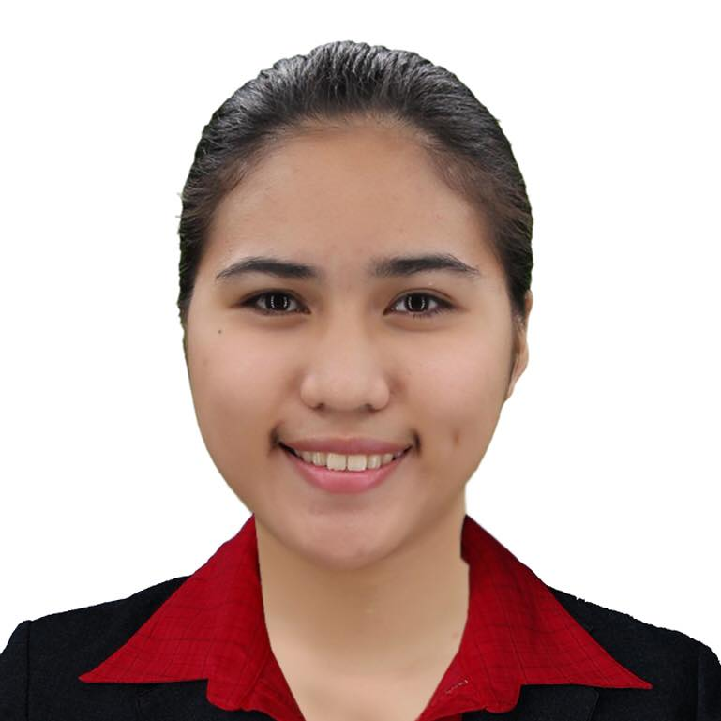 |  | LILIAN CAMILLE D. CAMACHO  EDUCATION  TERTIARY|LORMA COLLEGES|BACHELOR OF SCIENCE IN TRAVEL AND TOURS MANAGEMENT  Carlatan, City of San Fernando, La Union  2013 - 2018  SECONDARY| FELKRIS ACADEMY, INC.  Lingsat, City of San Fernando, La Union  2009 - 2013  PRIMARY| CATBANGEN CENTRAL SCHOOL  Catbangen, City of San Fernando, La Union  2003 - 2009  WORK EXPERIENCE  LORMA COLLEGES | STUDENT AFFAIRS OFFICE ASSISTANT  Carlatan, City of San Fernando, La Union  February 24, 2020- Present  LORMA COLLEGES | INSTRUCTOR  Carlatan, City of San Fernando, La Union  January 2019–May 2019  LAFAAYETTE LUXURY SUITES | FRONT DESK CLERK  Baccuit Sur, Bauang, La Union  October 2018–January 2019  OCEANLINK INSTITUTE, 2GO GROUP INC.| 5 DAYS APPRENTICESHIP BY EXPERIENCE (APEX) PROGRAM  April 14, 2016- April 18, 2016  SEMINARS/ CONFERENCES/ EXPOSITIONS  COMMUNITY TOUR GUIDING WORKSHOP  ABC HALL, City of San Fernando, La Union  August 13-18, 2019  COB TRADE EXPOSITION 2019: SKILLS COMPETITION| EVENT ORGANIZER  Lorma Colleges, Pavilion  May 11, 2019  ASEAN YOUTH FORUM  Oasis Country Resort and Hotel, City of San Fernando, La Union  September 14, 2017  PROFESSIONALISM AND WORK ETHICS IN THE TOURISM AND HOSPITALITY INDUSTRY  Lorma Colleges, Audio Visual Room, City of San Fernando, La Union  November 28, 2016  LIFE IN A CRUISESHIP  Jewel Igorot’s Hidden Garden, KM4, La Trinidad, Benguet, Philippines  May 7, 2014

OBJECTIVE
To serve with utmost efficiency and to carry out the ideals of my profession anchored to what is expected of me as a worker.

PERSONAL DATA

AGE: 23 Years old
DATE OF BIRTH: July 21, 1997
CIVIL STATUS: Single
LANGUAGE SPOKEN: ILOKO, FILIPINO, ENGLISH

CONTACT
PHONE:
0998 324 9696

ADDRESS:
#66 LUBRIN HEIGHTS, CITY OF SAN FERNANDO, LA UNION

EMAIL:
camacholiliancamille@gmail.com

CHARACTER REFERENCES
MARIA JOSEFINA A. SORIANO
Students Cultural Activities and Sports Coordinator
LORMA Colleges
jsoriano@lorma.edu
0919 066 2949

MARC JOSHUA Z. SABANGAN
Web Developer and Designer
Freelancer
joshua19jo@live.com.ph
0917 438 4500

LESLIE A. LAURENA
Front Office Supervisor
Lafaayette Luxury Suites
emiramona.leslie.sales@gmail,com
0955-882-9283

