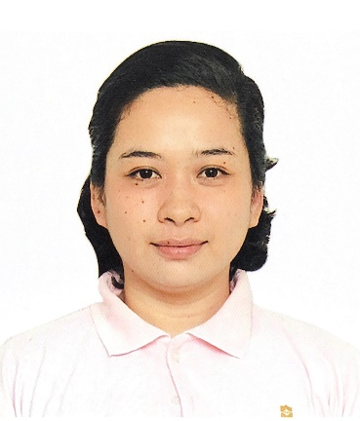
ADDRESS: 73D Scout Dr. Lazcano St. Brgy. Laging Handa Quezon City
Mobile number: +63 956-380-8560
EMAIL ADDRESS: jacklyngarganera@rocketmail.com
JACKLYN OLANDA GARGANERA
OBJECTIVE  WORK EXPERIENCEs |  | To land on a job that will continuously develop my knowledge and skills in a guest-oriented environment and will help achieve professional growth while helping the organization meets its objectives  Keystone Technical Institute of Lopez, Quezon  September 2,2020-March 5, 2021  LQMC Building, Anda St. Brgy. Talolong, Lopez, Quezon  Assistant Trainer  Carnival Cruise Lines | November 5, 2016- Present  Assistant Team Waitress  assigned in buffet stations during breakfast to lunch(LIDO) and dinner at the restaurant (American Set-up and service)  Novotel Manila Araneta Center | September 24,2015- September 26,2016  Food and Beverage Banquet Service Attendant  assigned in different kinds of occasions like wedding, baptism, birthday, meetings and big events.  Dusit Thani Manila | September 14, 2014 – April 11, 2015  Food and Beverage Attendant, Receptionist  assigned in the buffet restaurant in the Hotel which serves complimentary breakfast for the guests. I did reservations also for lunch and dinner for walk in guests
Coarse trainings and qualification |  | - Basic Training (STCW)  - Crowd Management Training  - Crisis Management Training  - Ships Security awareness training and seafarers designated duties  - Proficiency in survival craft and rescue boat  - MARLIS ENGLIST TEST  - Passport  - Seaman's Book  - C1-D US VISA  - B1-B2 US VISA  - Reference letter from Carnival  - Sea service from the employer/ Agency
EDUCATION  SKILLS, PERSONAl QUALITIES  personal InFORMATIoN |  | Polytechnic University of the Philippines (June 2010-April 30, 2014)  Bachelor of Science in Hotel and Restaurant Management  Keystone Technical Institute of Lopez (January – March 2021)  TESDA ACCREDITED SCHOOL  Food and Beverage National Competency Certificate  (March 8, 2021- March 7-2026)  • Food and Beverage with different kind of services.  • Basic Housekeeping services including laundry, make up room, turndown, butler and luggage  • Skirting  • Table set up (French, Russian, American, English)  • Table napkin basic folds and special folds  Height 161 cm  Age 27  Civil Status Single  Birthday February 5, 1994  Nationality Filipino  Religion Roman Catholic
ReFERENCEs
Mr. I Wayan Arcana
Former Head waiter/ Supervisor
Carnival Paradise
arcana3002@gmail.com | +62 818-0546-6578

Mr. Alex Casabuena
Novotel Manila Araneta Center
Novotel Manila Banquet Director
H7090-FB3@accor.com | +63 998-845-8219

Mrs. Rhodora A. Ulan
Keystone Technical Institute of Lopez, Quezon
School Administrator
keystonetechnical.lopez@gmail.com| +63 906-482-0119

