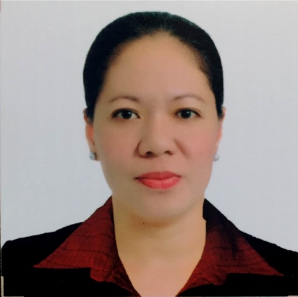
MARILYN P. RALLONZA
King Abdulaziz Medical City – Ministry of
National Guard Health Affairs
Hemodialysis North Center
P.O. Box 767, Riyadh KSA
011-2292562
MOBILE NO.: (966) 537312874
E-mail Address: marilyn.rallonza@yahoo.com

OBJECTIVES:
I would like to work for a company that will enhance the skills I already have as well as provide the opportunity for personal and professional growth and advancement opportunities.

DESIRED POSITION: Personal Support Worker

QUALIFICATIONS:
- Dedicated and hardworking individual
- Exceptionally versatile and adaptable
- Willing to render overtime
- Flexible and willing to try new things and interested in improving efficiency on assigned tasks
- Exposed with variety of personalities
- God-fearing person

SKILLS:
- Able to set up a 5008S Fresenius Dialysis Machine
- Oriented in Microsoft Office application (basic procedure)
- Perform dialysate and water sampling from Dialysis Machine
- Priming of 5008S Fresenius Dialysis Machine
- Changing of Diasafe filter

WORK EXPERIENCE

August 13, 2014 to present PATIENT CARE TECHNICAIN
Hemodialysis North Center
King Abdulaziz Medical City – Ministry of
National Guard Health Affairs
P.O. Box 767, Riyadh KSA
011-2292562

September 2012-July 2013 PRIVATE DUTY NURSE
Home Setting (Chinese Family)
Greenhills, Manila, Philippines

December 2011-August 2012 PRIVATE DUTY NURSE
Angels of Medical Care
Dubai, U.A.E.

May 22, 2009-November 29, 2011 NURSE AIDE (Out Patient Department)
Al Mouwasat Hospital (Jubail)
P.O. Box 10028 – Jubail Industrial 31961 KSA

August 2002-May 2009 NURSING ATTENDANT
Dayos-Pascual Medical Clinic
Rang-ayan,Roxas, Isabela 3320 Philippines

November 2001-August 2002 VOLUNTEER NURSING ATTENDANT
Manuel A. Roxas District Hospital
San Antonio, Roxas, Isabela 3320
Philippines

EDUCATIONAL BACKGROUND

1999-2001 SAINT PAUL UNIVERSITY
Tuguegarao, Cagayan, Philippines
College of Nursing
Midwifery Course (Graduated)

1995-1998 CENTRO ESCOLAR UNIVERSITY
College of Nursing
Bachelor of Science in Nursing (Undergraduate)

1993-1994 UNIVERSITY OF SANTO TOMAS
College of Nursing
1-year Health Aide Course
(Graduated with Certificate)

PERSONAL DATA

Age 45 years old
Birthdate: February 19, 1976
Birthplace: Camiling, Tarlac, Philippines
Sex Female
Civil Status Single
Citizenship: Filipino
Religion: Roman Catholic
Nationality Filipino
Language spoken English, Arabic, Filipino

