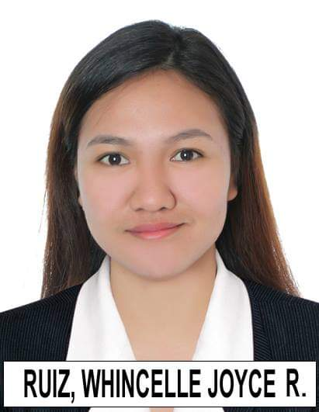
WHINCELLE JOYCE R. RUIZ
MACATAL, AURORA, ISABELA 3316
09214489017
05.whincelleruiz@gmail.com

PROESSIONAL EXPERIENCE
    - Pharmacist
      - Southstar Drug Inc.- San Jose City, Nueva Ecija, Philippines
October 17, 2018 - Present
        - Interpreted prescription orders, dispensed medications and counseled patients on drugs.
        - Interpreted prescriptions from healthcare providers to properly dispensed medications and health products.
        - Assisted patients with over-the-counter medicines and responded to questions concerning drug interactions.
        - Educate patients about possible drug interactions and gave special administration instructions.
        - Taught patients how to use medical devices such as glucometers and blood pressure monitoring device.
        - Assisted patients in minimizing medical expenses by recommending generic alternative prescription medications.
        - Check medication bottles for proper labeling before allocating to patients.
SEMINARS/ TRAININGS ATTENDED
- SOUTHSTAR DRUG Pharmacist’s National Summit
August 2019
- Advances in Pharmaceutical Dosage Forms
May 12, 2020
- Partners Against Pain: A Pain Advisor Program for Neuropathic Pain
June 26, 2020
- Complexities of Drug and Vaccine Development
June 30, 2020
- Potential Drug Interactions in the Treatment and Management of COVID-19
July 7, 2020
- Partners Against Pain: A Pain Advisor Program for Medication Counseling for Patients Experiencing Pain
July 10, 2020
- PPhA Juan Healthy Lung Pharmacist’s Training Program
July 13, 14 and 20
- Make Everyone Breathe Better: The Asthma Treatment Strategy
September 11, 2020
- Addressing Misinformation Through Pharmacists Provision of Pharmacy Information Services
August 13, 2020
- Ensuring Medication Safety Through Pharmacy Interventions
October 15, 2020
- COVID-19 Vaccines: The Pharmacist Addressing Mistrust and Misinformation
March 19, 2021
- Fitting into the Digital Milieu Through Digital Pharmacy
April 22, 2021
- Pharmacist’s Partners in Adult Vaccination
May 28, 2021
PRE-PROFESSIONAL EXPERIENCE
- Major Pharmacy Internship
Region 2 Trauma and Medical Center
Bayombong, Nueva Vizcaya
360 Hours
- Manufacturing Pharmacy Internship
Swisspharma Research Laboratories, Inc.
Barrio Pittland, Cabuyao, Laguna
200 Hours
- Hospital Pharmacy Internship
Gov. Faustino N. Dy Sr. Memorial Hospital
Calamagui 2nd, Ilagan City, Isabela
200 Hours
- Community Pharmacy Internship
Mercury Drugstore
Cauayan City, Isabela
200 Hours

EDUCATIONAL BACKGROUND
- Tertiary Education
School: Saint Mary’s University
Degree: Bachelor of Science in Pharmacy
Address: Bayombong, Nueva Vizcaya
- Secondary Education
Doña Aurora National High School
Address: Aurora, Isabela
- Primary Education
Macatal Elementary School
Address: Macatal, Aurora, Isabela
PERSONAL INFORMATION
- Birthday: November 5, 1996
- Birthplace: Macatal, Aurora, Isabela
- Age: 24
- Citizenship: Filipino
- Religion: Roman Catholic
- Height: 5’1’’
- Weight: 110.231 lbs
CHARACTER REFERENCES
Mrs. Melchora Bautista, RPh, MSPharm
Head, Pharmacy Department, Saint Mary’s University
Solano, Nueva Vizcaya, Philippines
Contact Number: 0977854446

Mrs. Marjorie C. Bautista
Store Manager, Southstar Drug Inc.
San Jose City, Nueva Ecija
Contact Number: 09154339817

I hereby certify that the above information is true and correct to the best of my knowledge and belief.

Whincelle Joyce R. Ruiz, RPh
Applicant

