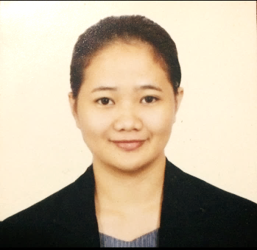
BENESSA MAE D. GABRITO
Real Street Brgy. Guintagbucan Abuyog, Leyte
0995-734-3128
bdgabrito@gmail.com

Career Objective:  To acquire valuable knowledge and skills to complement those that I have learned in school, as well as to provide opportunity for personal and professional growth. | Organizational Affiliations:
  Sports Development Officer-University of the Philippines Visayas Tacloban College (2016-2017)
  Junior People Management Association of the Philippines (JPMAP) Member-University of the Philippines Tacloban College (2013-2017)
Core Competencies:  - Has the ability to create and facilitate a team environment designed to increase productivity.  - Has initiative and determination to do and finish tasks at a given period of time.  - Can handle administrative details under pressure  - Able to resolve conflicts  - Can easily adapt to high stress, fast paced environment with multiple responsibilities. | Technical Skills and Eligibility:  - Computer literate and skilled in MS Windows 7,8 and 8.1servers, MS Word, MS Powerpoint, MS Excel, MS Outlook, MS Access, Adobe Photoshop, Gimp and HTML  - Civil Service Examination- Professional Level Passer
Educational Profile:
2013-2017 | Bachelor of Science in Management  University of the Philippines Visayas Tacloban College
2011-2013 | St. Therese Educational Foundation of Tacloban Inc.  Brgy. 91 Abucay Tacloban City
2009-2011 | St. Therese Education Center of Leyte  Brgy. 91 Abucay Tacloban City
2003-2009 | Bernardo V. Closa Central School  Real St. Bito Abuyog, Leyte

Career-Related Experiences:

- Junior Administrative Assistant
Responsible Internet Sustainability Effort Incorporated
6th Floor, Crown 7 Business Center, Kasambagan Cebu City
July 22,2019-December 20, 2019

- Administrative AIDE VI
Department of Agriculture Regional Field Office 7
M.C. Briones St. Maguikay Mandaue Cebu
November 2017-December 2018

- Career Congress 2017
Participant
February 18-19,2017
Ritz Tower de Leyte

- Building Capacities of Micro-Entrepreneurs in Yolanda Displaced Communities in Tacloan City for Sustainable and Resilient Livelihoods
Participant
Eastern Visayas State University
January 10 ,2017

- Young Southeast Asian Leaders Initiative YOUnified ALL IN Tacloban Youth Expo
Participant
Leyte Normal University
December 3, 2016

- Gender Development and Gender Sensitivity Training for BFAR Employees
Organizer
Leyte Park Hotel
November 28-29,2016

- US Embassy-Go Negosyo Youth Entrepreneurship Development Workshop (YEWD) Mentor Me Innovation Forum
Participant
University of San Carlos Cebu City
July 14, 2016

