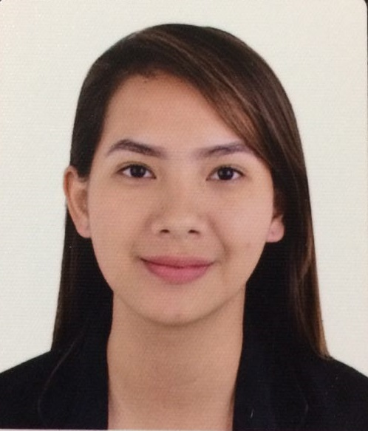
HESED LOLYN C. ROBIN
East Balabag, Valencia, Negros Oriental
hesedlolynrobin@yahoo.com
0997-314-0933

CAREER OBJECTIVE

To be part of a fast growing hospital that offers the best career development that will enable me to use and enhance my knowledge, communication and interpersonal skills and be a partner in achieving their goals.
To obtain a position that will effectively utilize my skills, the opportunity to work with a team and serve the hospital and patients.

PERSONAL INFORMATION

Age : 22 years old
Date of Birth : October 24, 1994
Place of Birth : Tagbilaran City, Bohol
Citizenship : Filipino
Religion : UCCP- Protestant
Civil Status : Single
Height : 5’2’’
Weight : 48 kg

EDUCATIONAL BACKGROUND

Bachelor of Science in Nutrition and Dietetics
Silliman University
Hibbard Avenue
SY 2011-2015
Silliman University High School
SY 2007-2011
Silliman University Elementary School
SY 2002-2007

SKILLS AND QUALIFICATIONS
- Flexible and willing to work with different personalities
- Proficient in Microsoft Word, Excel, and PowerPoint
- Proficient in English, Tagalog and Cebuano
- Highly organized and efficient
- Ability to work independently or as a part of a team
- Ability to motivate

EXPERIENCES
WORK EXPERIENCE

OIC, Unit Head (Nutritionist-Dietitian)
Dietary Unit, Visayas Community Medical Center, Cebu City
July 2016 - October 2016 (staff)
October 2016 - present (OIC, Unit Head)

TracFone Customer Service Representative
Qualfon, Dumaguete City
November 2015- May 2016

Practicum III – Actual Hospital Exposure

Silliman University Medical Center Foundation Incorporation
Negros Oriental Provincial Hospital
February 2015 – March 2015

Practicum II – Actual Foodservice Exposure

Silliman University Nutrition and Dietetics Snack shop
Silliman University Cafeteria
Silliman University High School and Elementary Canteen
January 2015- February 2015

Practicum I – Actual Community or Public Health Exposure

Barangay Calindagan, Dumaguete City
November 2014 - December 2014

SEMINARS AND TRAININGS
Joint Convention of NDAP and PAN themed “The Power of Nutrition in the First 1,000 Days”
Cebu Country Club, Gov. M Cuenco, Banilad, Cebu City.
July 28, 2016

PADE and ADNEP workshop themed “New Trends in Diabetes Workshop”
Sacred Heart Center, Dionisio Jakosalem St., Cebu City
October 15, 2016

NDAP-CEBU Convention themed “NDs Getting Stronger in their Passion & Commitment for Excellence in Nutrition Care”
Cebu Provincial Capitol, Cebu City
July 5-6, 2017

AACE-Philippine Chapter Annual Nutrition Summit themed “Nutrition in Hospitalized Patients: Consensus & Controversies
Radisson Blu Hotel, Cebu City
August 2, 2017

AACE Joint Annual Clinical Congress themed “Decision Making & Approaches in Diabetes and Endocrinology”
Radisson Blu Hotel, Cebu City
August 3-5, 2017

CHARACTER REFERENCES
MS. NILDA BENOLIRAO
Nutritionist-Dietitian
Vicente Sotto Memorial Medical Center, Cebu City
Mobile: 0922-405-5642

MR. JONIEL PERFECIO
Department Head of Community Health Services-Community Development Program
Visayas Community Medical Center, Cebu City
Mobile: 0906-270-7268

MS. HAZELLE MALAZARTE
Department Head of Support Services
Visayas Community Medical Center, Cebu City
Mobile: 0933-973-2231

