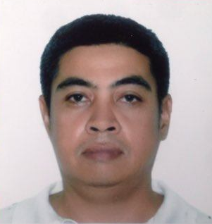
Name: Romeo Torrente Jr.
Address : Blk 20 Lot 22 Grandroyale Subd. Bugallon, Pangasinan
Contact No. 0951 542 4546
E mail Add. nonoterrazola@gmail.com

Objective:
To secure a challenging position in a reputable organization to expand my learnings, knowledge, and skills. Secure a responsible career opportunity to fully utilize my work experienced and skills

Educational Background:
College: Catanduanes College Bachelor of Science in Commerce
Virac, Catanduanes Major in Management (2001)
High School: Catanduanes College 1996
Virac Catanduanes
Primary: Baras Cental Elem. School 1992
Baras, Catanduanes

Work Experience:

April 2020 – Present Construction Welder Fabricator

June 2018 – March 2020 BENN General Mdse. Utility Driver
Makati City
April 2017 – May 2018 Lite Express Int’l Driver / Courier
Cubao, Quezon City
June 2002 – March 2017 Village School of Parkwoods School Service Driver
Quezon City Philippines

May 2001 – May 2002 Rustan’s Comm’l Corp. Receiving Clerk
Ayala Ave, Makati City

Personal Background:
Name: Romeo Torrente Jr.
Address: Blk 20 Lot 22 Grandroyale Subd. Bugallon, Pangasinan
Date of Birth: Feb. 11, 1980
Age: 41
Civil Status: Married
Weight: 64kgs
Height: 5’5
No. of Children: 3
Name of Spouse: Sheila E. Torrente
Contact in case of Emergency: Sheila E. Torrente 0912 939 9858
Prof. Drivers Lic. Date of Expiration Feb. 11, 2023 RES. 123

Character References:
Mr. Jorge Dimaculangan Bureau of Fire Protection Fire Chief
Infanta Fire Station
Infanta, Pangasinan
Mr. Francisco F. Aquino Administrative Officer Village School of Parkwoods
Quezon City
Mr. Elmer Manuel Police Officer Pangasinan Prov.’l Police Office
Lingayen, Pangasinan

I hereby certify that the information is true and correct to the best of my knowledge.

Romeo Torrente Jr.
Applicant

