EXPERIENCE AND ACHIEVEMENTS

Sep,2019 | Maintenance Executive
Sep,2019 | Loparex India Pvt Ltd.
 | Implemented 5S,Kaizens and ISO
 | Documents PM activities ,RCA,CAPA
 | Energy Report Work planning ,EM
 | project work.

Jun,2019 | Maintenance Engineer
 | Galva Deco parts Pvt Ltd.
Planning ,controlling and execution of all electrical Instruments. Activities involving like cable tray ,cable laying MCC,PCC installation Electrical panel testing and trouble shooting

Sep,2012 | Maintenance Officer
Sep,2012 | Durga Processor Pvt Ltd.
 | Plan day to day activities, ensure
 | quality of work as standard
 | working knowledge of performing
 | operation of utility and plant
 | areas, maintenance of pump
 | ,valves, pneumatics, sensors ,etc.

GAURAV AGRAWAL
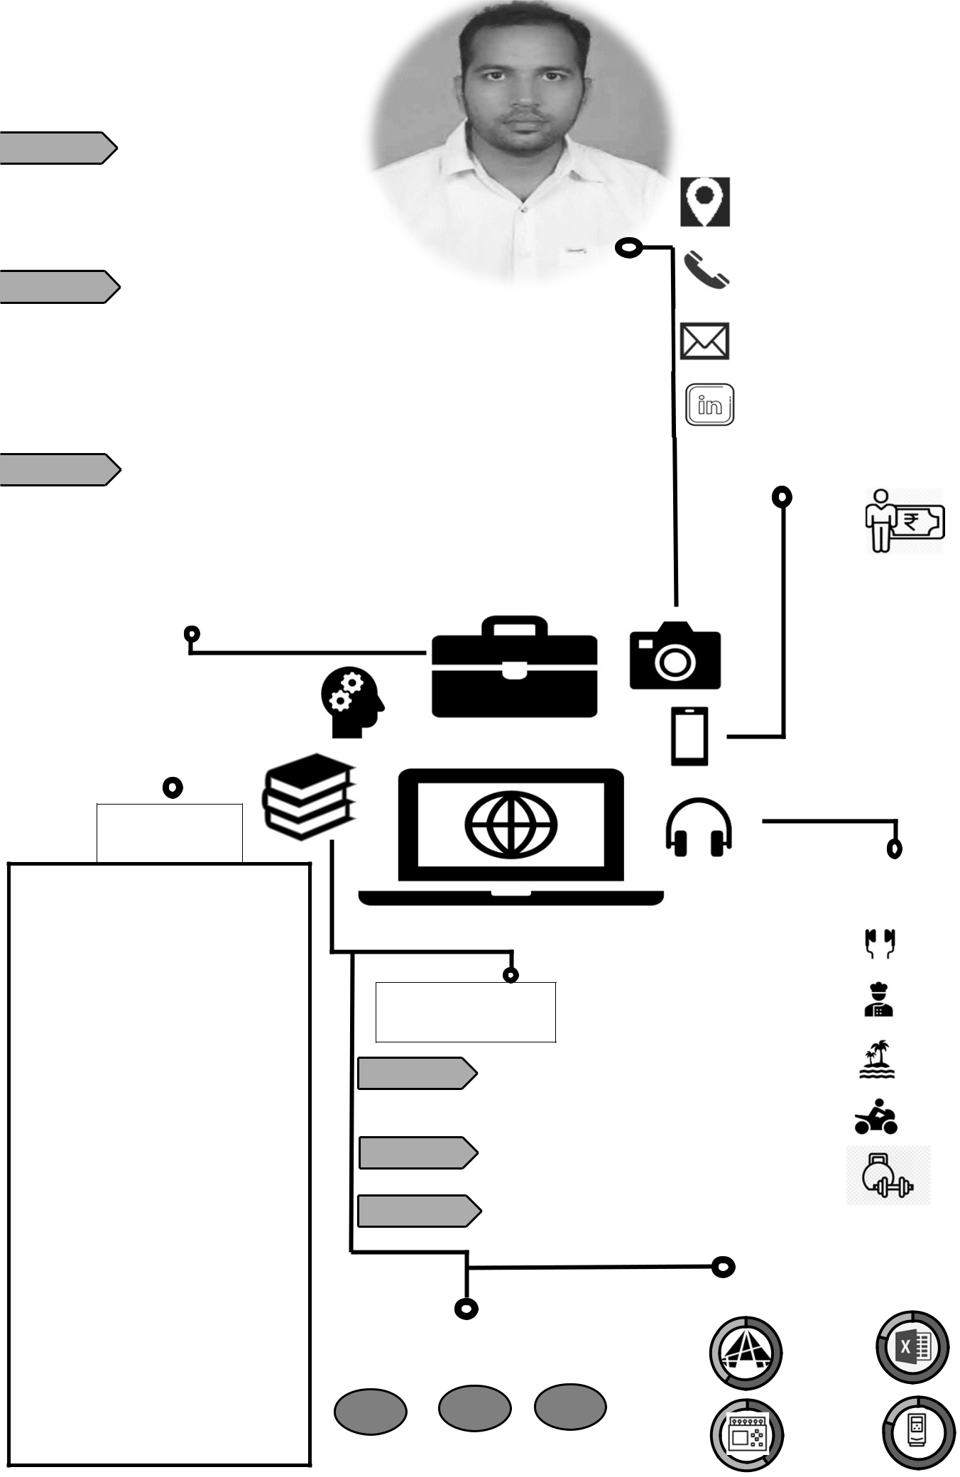

“ Working well or completing

against a standard of excellence taking responsibility for ensuring that work is completed within specified time and quality parameter. Avoid problems and visibly impacts job results. Team work for genuine intension with work with other to be part of a team to work together to accomplishing organizational goal.
“

CONTACT

44 A, Bahgyoday Society ,Chala Vapi Gujarat 396191

+91-7567213060

gauravcrj@gmail.com

gaurav-agrawal-56025539

Current CTC : 5.5 LPA Expected CTC:

SKILLS

Operation and Maintenance of respective utilities and Plant area.
Working knowledge on handling troubles and implementation of Basic RCA tools.
Knowledge of TPM,5S,6S,Kaizens , Continuous Improvement projects.
Practice in work environment of ISO 9001, HIRA and safety practices.

Responsible to make updated list for critical spare and to monitor inventory.
Plan day to day activities manage manpower as per priorities.
Planning and implementation of preventive maintenance schedules of various machines to increase up time and reliability.

Trouble shooting all technical problems arising in functioning of PLC, instruments, controller control valves transmitter sensors indication etc

Maintaining record as per ISO standard and updating them according to revision.
Handling project activities working in various requirement w.t.r to utilities, machines, manpower and monitoring.

 |  |  | HOBBIES
 |  |  |  | Music
EDUCATION |  |  |  | Cooking
2007-2011 | Sherwood College of Engineering |  |  | Exploring
2007-2011 | Research And Technology (UPTU)
 | B.Tech Electronics And Communication (64.38%) |  |  | Long ride
 | Kendriya Vidyalaya, Chittaranjan |  |  | Long ride
2005-2007
2005-2007 | Senior Secondary ,CBSE (70.33%) |  |  | Workout
2004-2005 | St Joseph Convent High School
2004-2005 | High School ICSE , (77.66%)
 |  | TECH. SKILLS
LANGUAGES |  |  | Auto Cad | MS Excel
95% | 90% | 70% | PLC I/O | VFD
English | Hindi | Bengali | PLC I/O | VFD

GAURAV AGRAWAL

B.Tech in Electronics and Communication Contact Information

Cal: +91-7567213060

Email: gauravcrj@gmail.com

Analytical, particular and quality-oriented professional with an eye for detail; targeting assignments in Maintenance operations with an organization of repute preferably in FMCG, Automobile and Manufacturing industry.


High-performing, results-focused Maintenance Engineer with nearly 6.5 years of experience in: Strategizing Operations & Maintenance Project Management, Plant Operations, Manufacturing Operations, Process Enhancements Team Management, Talent Management and Capability Development. Proven success directing quality and process improvement initiatives in applying projects for designing & development, manufacturing and commissioning within defined parameters for increasing productivity. Effectively supervise, train, and motivate staff, scheduling company employees with vendors; build cooperative teams, staying engaged with all staff members to develop and instill a genuine team spirit.

Extensive knowledge of coordinating plant including planning, scheduling & implementing plant capacity enhancement a con of SOP, quality and safety guidelines. In-depth knowledge of implementing standardized project management methodologies, cost controls, and best practices; manage daily operations, prioritize resources, and develop creative solutions to broad issues. Enhanced capabilities to maintain strong and positive professional relationships with both superiors and subordinates. Expert at adjusting work pace to accommodate emergencies or changing client needs. A dynamic change agent, skilled in repositioning organizations to achieve operational and manufacturing excellence

CORE COMPETENCE
PLANT OPEARTION

UTILITY MAINTENANCE

EM PROJECT MANAGEMENT

CRITIICAL SPARE MANAGEMENT VENDOR DEVELOPMENT
SAFETY AND COMPLIANCES PREVENTIVE MAINTENANCE
INSTALATION AND COMMISIONING PLC

VFD HVAC
MS EXCEL

CONTROL WIRING AUTO CAD
UTILITY MANGEMENT ISO DOCUMENTATION
MANPOWER MANAGEMENT LOCK OUT TAG OUT,PPE,BBS ISO DOCUMENTATION
INTERNAL AUDITS STANDARDS

TROUBLE SHOOTING TECHNICAL PROBLEMS

MTTR AND MTBF

AHU,CHILLER,COOLING TOWER,HVAC

PUMP,BLOWER ,PNEUMATIC,HYDRAULIC FIELD ELEC AND MECH INSTRUMENTS P & I UNDERSTANDING
ELECTRICAL DRAWING

KAIZEN,5S,WHY-WHY,FISH BONE,RCA,CAPA KPI


PROJECTS

TITLE: Installation and Commissioning of 380KW back pressure turbine. AUG 2016

ACTIVITIES

- Making of bill of material as per requirement and specification.

- GA foundation marking and anchorage of turbine.

- Pipe line scheduling and fabrication with instrumentation pipping such as DPT, Pressure gauge ,Safety valve, Pressure reducing valve, Pressure transmitter, Temperature Transmitter.
- Power cable and control cable scheduling and termination plan and schematics.

- Monitoring of project progress Testing and Commissioning.

- Dealing with contactor.

TITLE: Installation of 8 head Rotary Printing machine. | JAN 2017

ACTIVITIES

- Utilities a viability at machine such as water ,Pneumatic ,Steam , Thermic fluid.

- All material indent and follow up the delivery .

- Preparation of cable schedule ,JB schedule cable tray routing and fabrication accordingly.

- Machine panel installation cable termination for control and power .

- Field instruments fitting and calibration such as proxy , limit, pressure switch ,load cell ,Potentiometers , Hydraulic and pneumatic schematics. VFD programming and termination plan.

TITLE: APFC panel upgradation from manual to auto . | JUN 2017

ACTIVITIES

- Panel design in AUTO CAD accordingly to our requirement with consultation of HOD and assigning vendor for panel building.

- All related material indent and procured the same as per specification.

- Control wiring schematic preparation as well as in house wiring and termination done and programming of Power factor controlling relay done.

- Testing and commissioning

TITLE: 1750 KVA DG installation ,commissioning and synchronizing | SEP 2018

ACTIVITIES

- 1750 kva DG cable tray and cable routing and termination at LT panel.

- Cooling tower erecting and piping for DG cooling system . Making of diesel line for the same .

- Synchronization panel commissioning with 650 KVA and 1750 KVA DG set with help of vendor.

TITLE: JUMBO Slitting machine panel upgradation. | FEB 2019

ACTIVITIES

- Bill of material indent and follow up.

- Old panel disconnected and E waste

- Cable tray routing and cable laying as per schedule

- Termination of cable both panel as well as field side additional load cell installation for better controlling.

- Unwinder side hydraulic arm wiring done and control logic checked .

- VFD , and HMI installed as well as electropneumatic valve are connected to both lay cylinder for better winding and production quality.

- Pneumatic pipe schematic designing and connecting.

- Testing , commissioning and handed to production.


MAINTENANCE EXECUTIVE

SEP,19 – Present | SILVASSA

 LOAPREX INDIA PVT LTD

Responsibility to take care of automation and field instrumentation related activities in production machineries.

Active part of process / capacity improvement projects as apart of CAPEX investment.

Responsible for preventive Maintenance Job planning and execution through team of technicians. To conduct CAPA and RCA of repetitive technical issues in production machineries.

Maintaining records and documentation as per ISO standards and updating then according to revision. Project activities involving working out various requirement with respect to Utilities , Machines and

monitoring.

Preparation of daily energy consumption and EM report .

Implementation of PM activities accordingly as per given schedule material arrangement for the same. Vendor development

Carry out EHS related task.

Regular attending training as per plan given my management.

Document preparation for Audits accordingly as per given instruction Maintain 5S facility in the workplace.

Performing and implementation of Kaizens.

Monthly analysis of MTTR, MTBF and to do WHY-WHY analysis, RCA and CAPA of particular breakdown.

Technical Know How

- Chiller monitoring and observation of 30tr, 50tr, 100tr Air cooler Voltas make chiller units.

- Parameter monitoring of Gas fired thermo pack unit.

- Checking of IBR boiler and steam generator.

- Air compressor unit 3nos Atlas Copco Screw compressor.

- Uses of thermocouple ,Load Cell Controller, load cell amplifier , Proximity Switches , Web guider etc.

- Programming of VFD and trouble shooting.

- Modification and logic development of control system for more efficient and safety operation of machine equipment as well as human.

- Looking after the APFC panel, LT panel, UPS system, and 3 Phase voltage stabilizer. PPC,UPS

- Performing AMC of Diesel genets 600 KVA Caterpillar make.

- AHU unit maintenance and its peripheral equipment’s

- Looking after the Break down of Coating ,Slitting ,Packing lines , Printing machines and reducing the down time of the line.

- Utility and al peripheral devices PM, Breakdown maintenance , predictive maintenance, Corrective Action.

- Trouble shooting of MAXXON burner unit it damper servo motor , PID controller calibration and programming , ultrasonic sensor , spark plug and regular PM activities to ensure zero down time.

- Web guider unit installation and commissioning .

- Online image processing unit know how it regular PM activities work carried out.

- Thermoregulator installation and trouble shooting to maintain in limit temperature accordingly to process requirements.

- Plant facilities maintaining accordingly to ISO compliances.

- Identification label and instrument ID updating in regular intervals.

- Load cell calibration for tension control mode operation .

- Actively involvement in Project upgradation work with improvement actives KPI.

- Regular monitoring that all maintenance related KPI at in within limits.

MAINTENANCE ENGINEER

JUN,19 – AUG,19  BHILAD


GALVA DECOPARTS PVT LTD
Preparation of documents for internal as well as external audits. Review of daily data sheet documentation for machines

Planning of shutdown work

Stock maintaining and maintain critical spare part list.

Maintenance of logbook of daily job work and improving it for minimum breakdown. Making of monthly shift schedule of the team.

5S and Kaizen activities

Technical Know How

•Daily preventive maintenances of Chiller units gained knowledge of Chiller working principle and troubleshooting.

•Hot water burner system its trouble shooting and thus ensuring smooth working of plant utility •To ensure that all the water scrubbers are working fine or not. •Uses of thermocouple

•Programming of VFD and trouble shooting.

•Modification and logic development of control system for more efficient and safety operation of machine equipment as well as human.

•Looking after the APFC panel, LT panel, UPS system, and 3 Phase voltage stabilizer. PPC,UPS •Performing AMC of Diesel genets 1750 KVA sterling Wilson make. •AHU unit maintenance and its peripheral equipment’s

•Looking after the Break down of Plating Line and reducing the down time of the line.

•Automatic Transporters maintenance there PM, Breakdown maintenance , predictive maintenance, •Some logic and parameter changing according to system requirement and thus increasing the production round

•Recipe up gradation with production team to increase production.

•Trouble shooting of Plastic injection molding machine , repairing of MTC,HRS, Suction unit, molding machines of Fanuc Roboshot and diagnosis the problem.


MAINTENANCE ENGINEER

SEP,12 – MAY,19 | SURAT

 DURGA PROCESSOR PVT LTD

Planning & implementing production operations in coordination with the other functions

Following standard operating procedures, manuals & work instructions for operations for the unit

Supervising installation & commissioning of various equipment along with machines

Facilitating planned/ preventive/ predictive maintenance of critical and non-critical equipment Anchoring on-site construction activities to ensure completion of project within the time & cost

parameters and effective resource utilization to maximize output Tracking project progress and taking steps for mitigating any risks

Technical know how

- Knowledge and trouble shooting of PLC and understanding of control logic and thus modification of it according to application

- Have gained knowledge of PLC programming

- Allen Bradley Micro logic 1200 and working on RS logic 500 software for application development

- Uses of PID Controller Limit Switches, Proximity Sensor, Relay Logic Pressure TX, Pressure Switch, Temperature TX, Flow Control Valves, Pressure reducing valve , Differential pressure transmitter, Pressure vessels, Pneumatic and hydraulic logic.

- Variable Frequency of ABB 550/400/145/350 Series, DELTA VFD M/F/B series & Yaskawa A1000 drive and programming it for specific application

- Centrifugal pump, Blowers, Screw and Reciprocator Compressor parameter setting and preventive maintenance.

- Calibration of flow transmitters and pressure transmitters.

- Electrical SLD knowledge and control circuit diagram .

- Daily check list of boiler maintenance looking after the boiler of 10TPH. 14TPH

- Optimization of boiler performance.

- Boiler breakdown maintenance looking after the ESP, water scrubbers, multistage feed pump , Moberly switch, fugi plug, APH, dust collector.

- Air compressor screw compressor of Ingersoll rand and reciprocator compressor it's daily PM.

- Troubleshooting of machinery control panel

- Installation and commissioning of Induction Generated Turbine of 350KW and executing charge thorough inspection and daily reporting summary of the power produced

