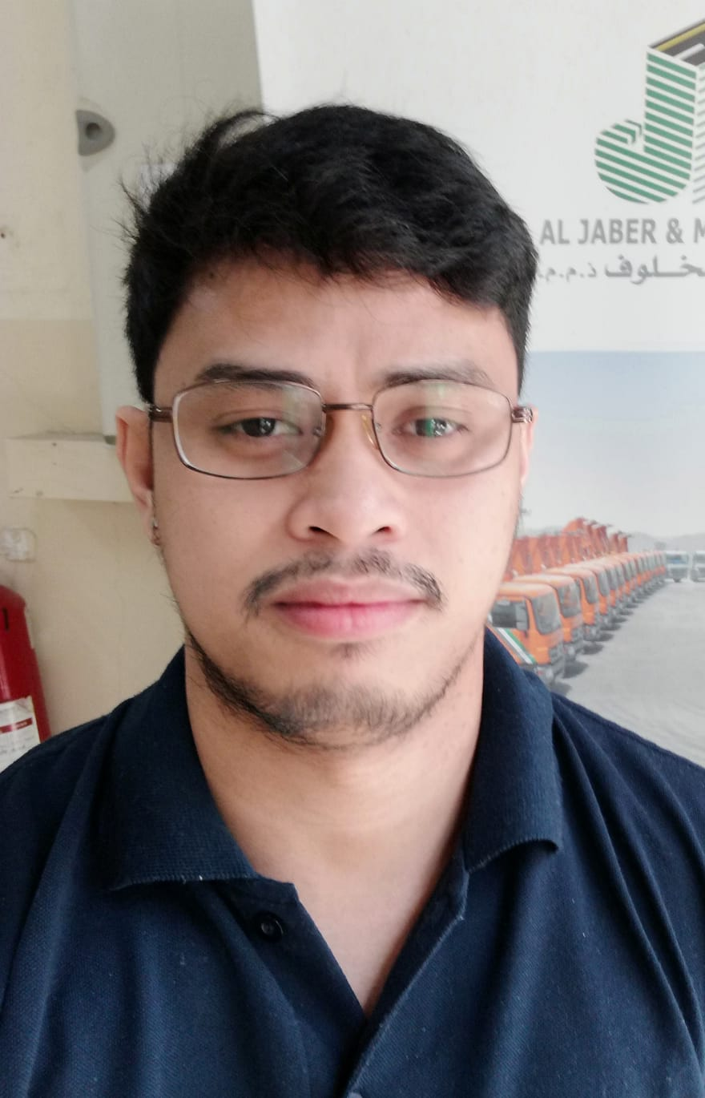
Leonard S. Tecson
Al Ezz Compound, Mhadinat Khalifa North, Doha, Qatar
Mobile: +974 3021 5309
Email: leonard.salise@yahoo.com

EDUCATION
Bachelor of Science in Marine Transportation, Maritime Academy and Training Institute, Philippines 2016

NATIONALITY
Filipino

Civil Status
Married

BIRTHDAY
07 February 1993

Career Objective
To obtain a challenging and responsible position in an organization that can fully utilize my abilities, experiences, and key strengths. Passionate about achieving a promising role that allows meaningful contributions to a business success. I consider myself as a dedicated and independent worker with strong initiative and commitment to excel, hardworking and energetic; flexible; adapt easily to change of environment and work schedule.

Knowledge and Skills
- Fully competent in use of Microsoft Office (Windows 95/98/200/XP Operating Systems, Microsoft internet browsers.
- Flexible, proactive, goal oriented, expressive, gregarious, patient, self-motivated and persevering.
- Fluent in conversational Filipino and English
- Has good leadership in special and oriented activities.
- Has strong commitment in task assigned. Team spirited, being able to work well with others at the same time inspiring cooperation among co-workers and clients.

Work Experience
Document Controller / Administrator – JH Construction WLL (formerly – Al Jaber & Makhlouf WLL)
PMV-EMOD
Orbital Asphalt Plant – Mesaieed, Qatar
September 2018 – Present

- Copy, scan, and store documents
- Check for accuracy and edit documents, like contracts, invoices and other related.
- Review and update technical documents (e.g. manuals and workflows)
- Distribute project-related copies to internal teams.
- File documents in physical and digital records.
- Create templates for update or future use.
- Retrieve files as requested by projects or clients.
- Manage the flow of documentation within the organization.
- Maintain confidentiality around sensitive information and terms of agreement.
- Prepare ad-hoc reports on projects as needed.

Weighbridge Operator – Document Controller – JH Construction WLL (formerly – Al Jaber & Makhlouf WLL)
Orbital Asphalt Plant - Mesaieed, Qatar
June 2018 up to September 2018

- To operate the weighbridge systems in accordance with the standard and efficient hand-outs, waste management permit and & procedures, and maintain reliable, adequate, and accurate records thereof in a timely manner.
- To process all relevant data/paperwork in an accurate and punctual manner in order assist site management in their day-to-day tasks.
- To provide a prompt & efficient service to haulage sub-contractors and to assist them wherever safe, practical, and necessary.
- To produce a report daily, weekly, monthly, and yearly with current stocks of materials.
- Acting as first point of contact for any vehicles to resolve any issues/problems with the delivery / collection of the goods e.g. if delivered too late, and reporting/recording accordingly.
- Ensuring that all Health & Safety measures are adhered to by any member of staff/person at the weighbridge facility, including the wearing of Personal Protective Equipment and advising them accordingly.

Seminar Attended
- Document Controller Management
ICON Training Centre
New Salata Doha Qatar
January 4, 2020

- Basic Occupational Safety and Health
JSU-PSU Mariner’s Court
Legaspi Ext., Cebu City, 6000 Cebu Philippines
January 15 to 20 2018

Character Reference available upon request.

