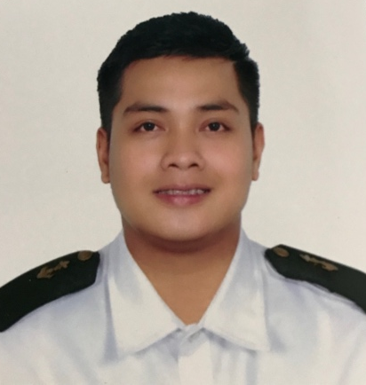
ROSCO MURILLO BENITEZ

218 Maraykit San Juan Batangas
Roscobenitez07@yahoo.com
09171923601

Career Objective:

To be given a position where I can utilize and contribute my skills. To give my highest standard of discipline, professionalism, excellent service, good moral character and loyalty to the company.

Skills:
- Hardworking
- Computer Literate

Educational Background:

Tertiary: Bachelor of Science in Maritime Transportation
Lyceum of the Philippines University
Lyceum International Maritime Academy
Cuta Batangas City
2011-2014

Secondary: Batangas Eastern Colleges
San Juan Batangas
2007-2011
Elementary: Batangas Eastern Academy
San Juan Batangas
1999-2007
Trainings Attended:
- Basic Training
Personal Survival Technique
Fire Prevention and Fire Fighting
Elementary First Aid
Personal Safety and Social Responsibility
- Proficiency in Survival Craft and Rescue Boats
- Proficiency in Fast Rescue Boats
- Basic training for oil and chemical tanker cargo operation
- Ship Security Awareness Training and Seafarer with Designated Security Duties
- MARPOL 73/78 Consolidated Annexes I-IV
- Catering Management
- Deck Watch Keeping- Rating Forming Part of Navigation Watch
- NCII smaw welding

Personal Background:

Age: 27
Date of birth: April 7, 1994
Gender: Male
Civil status: Married
Height: 5”11
Weight: 76kg
Nationality: Filipino
Religion: Roman Catholic

I hereby certify that the information above is true to my knowledge and belief.

-----------------------------------------------------
ROSCO MURILLO BENITEZ

