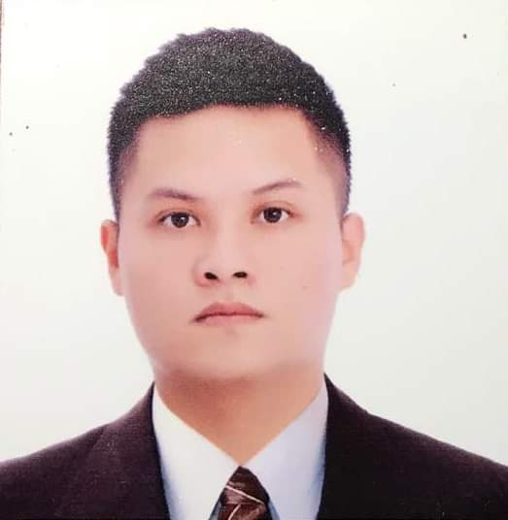

KENNETH RUSSELLE B. LIWANAG
484 Talakitok Street Dagat-Dagatan Caloocan City.
09158653009 / 09057694430
borja_1081@yahoo.com

CAREER OBJECTIVE
To be part of a progressive company that would further enhance my knowledge and skills as well as to contribute positively towards the attainment of the company’s objective.

QUALIFICATION AND WORK SKILLS
Hardworking, honest, active and has a good attitude towards work.
Can stand long hours of work and can handle shifting schedules.
Ability to learn quickly, Be creative and resourceful.
Strong interpersonal skills
Ability to work in a team
Success - driven and results -oriented.
Proficient in Windows-based computer programs such as Microsoft word, Excel and Powerpoint

EDUCATIONAL BACKGROUND

Tertiary Level
College of the Holy Spirit Mendiola
Bachelor of Science in Hotel and Restaurant Management
163 E. Mendiola, Manila
2011 - 2014

Science and Technology Institute
Hospitality and Restaurant Services
133 Quezon Avenue, Quezon City
2009 - 2011

Primary Level & Secondary Level
La-Consolacion College Caloocan City
416 A.Mabini Street Caloocan City
1997 - 2009

ACHIEVEMENTS AND AFFILIATIONS

TRAINING, SEMINARS ATTENDED, CERTIFICATION, AND WORK EXPERIENCE
- Lifestyle Courses, MOST INSTITUTE, MANILA CAMPUS (October 17, 2009)
- Project Management, STI College Quezon Avenue (HRS Society (November 4, 2009)
- Career Enhancement Training, STI College Quezon Avenue (January 22, 2011)
- Tempura Japanese Grill (Practicum) Robinsons Place, Ermita (February 2, 2011)
- Housekeeping, Front Office and F&B Seminar, Microtel, MOA (March 17-18, 2011)
- Housekeeping and F&B Section (Practicum) Microtel, MOA (March 2011)
- NU’VAINE Manila Superclub(Waiter) Q.C (May 2012)
- Locale Bar (Waiter) Q.C (August 16, 2012)
- Cebu-Bohol Educational Tour (Sept. 28-30, 2012)
- Management Educational Tour (Crimson Resort and spa Mactan (September 28, 2012)
- Hotel Operations Familiarization (City Garden Suites) (October 5, 2013)
- Excess Superclub (Waiter) Q.C (November 5, 2013)
- Discovery Suites Ortigas (Practicum) (January-March 2014)
- Celebrity Lounge Family Ktv Mandaluyong City (O.I.C) (Sept. 2014-2017)
- Highgrounds Dine.Coffee.Surf (Restaurant supervisor) Q.C (Jan. 2017-2019)
- The Palace B.G.C B.A.D (On call server) Taguig city (May-Nov 2019)
- Mplace South triangle Condominium (Receptionist) (Nov 2019.Feb 2020)
- FoodPanda (Delivery Rider) (Jan 2020 - present)
- Toktok Rider (Jan 2021- present)
- Lalamove Rider (April 2021- present)

PERSONAL INFORMATION
Nickname : Ken/Neth Citizenship : Filipino
Age : 28 Civil Status : Single
Birth Date : July 9, 1992 Religion : Catholic
Birth Place : Quezon City Height : 5’6”
Weight : 185 lbs

CHARACTER REFERENCES

Name | Institution | Contact Number
Lance I. Simpao | (Manager) Highgrounds | 09151152521
Jennefer Y. Yap | (Professor) St. Dominic College of Asia | 09228730587
Althofer G. Deguzman | (Supervisor) MPlace | 09958370088

I do hereby pledge that the information above is true:

Kenneth Russelle B. Liwanag
_______________________

