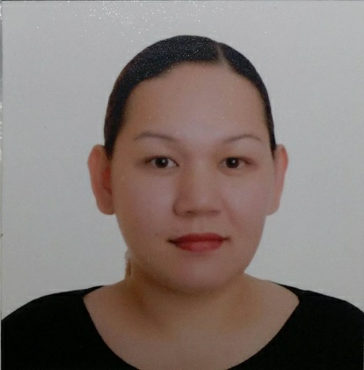
Ma. Patricia Margarita B. Zulueta

5th Street Lawaan Village
Balantang Jaro Iloilo, City
09175046406
ticia_23@yahoo.com

Seeking a position which will allow me to utilize the knowledge and skills I have obtained as a Registered Nurse. A position of responsibilities where my working capacities, professional and business efficiencies may contribute to successfully serve the organization in the best possible way with sheer determination and commitment for growth and development.

WORK EXPERIENCE

Cashier / Wait staff
Speakeasy Bistro - 2020 to 2021

Administrative Assistant

Work Description: Data encoding / appointment setting / flight booking / order receiving from clients
SG solutions - 2014 to 2015

NLE Head
RN International Review Center
November 2008 - March 2009

Oversees the whole PNLE Program
Plans and collaborates with the PNLE Team
Follow - up of Lecturers and Discussants (schedule of lecture, handouts,, post - tests,, topics to be discussed and time)
Schedules drills for students and assigns discussants for each topic
Assigns topics for research and coordinates with the Research Head
Evaluates lecturers, QA’s overall performance as well as student’s performance and attendance.
In charge of troubleshooting when simple/minor problem arises during the NLE program.
Approves excuse letters and other letters which concern the student’s performance except financial matters
In charge of National Lecturers (Conveys to and from the airport, hotel, etc.)
In charge of follow-up on new Philippine Nursing Licensure Exam Board Passers.

Quality Assurance Officer/ Discussant
RN International Review Center
July 2008- October 2008

Primary student proctor
In charge of the reviewees for the Nursing Licensure Review Program (attendance, exams, announcements, daily progress reports) Discussant for NLE Review Program

Administration and Registration Officer

RN International Review Center
July 2007- June 2008
Attends to inquiries about the different review programs.
Attends to enrollment of students.
Accepts and deposits daily cash payment
In charge of petty cash fund for the office.

EDUCATIONAL ATTAINMENT

2003- 2006 BS Nursing University of Iloilo
2000- 2003 BSMT Iloilo Doctor's College
1998- 2000 BSMT University of San Agustin
1994- 1998 High School Assumption- Iloilo
1988- 1994 Elementary Assumption- Iloilo
1986- 1988 Pre-School Assumption- Iloilo

SKILLS

  - Proficient in English, Tagalog and Hiligaynon
  - Has Basic Computer Skills such as Microsoft Word Power Point & Excel, Photoshop and is Internet Literate.
  - Willing to undergo training for development of knowledge
  - Has patience and passion in work

WORKSHOPS & SEMINARS ATTENDED

VIA Philippines
Understanding the VIA Platform Better:: A Comprehensive & Integrated Course
April 13,, 2013
Sarabia Manor Hotel,, Iloilo City

VIA Philippines
International Basic Course
June 6,, 2013
Hotel del Rio,, Iloilo City

JOHN CALUB
How to become a Money Magnet
November 20,, 2011
SM City Cebu

Domestic Violence
February 22, 2006

Nursing in the United States
February 20, 2006

Different Fields of Nursing
February 14, 2006

Teenage Empowerment
February 1, 2006

Integrated Comprehensive Nursing Licensure Exam
January 18, 2006

Newborn Screening
December 2, 2005

REFERENCES

Msgr. Excel N. Jaen, JCD
Parish Priest
Our Lady of Monserrat Parish
Gran Plains Subd.. Jaro,, Iloilo City

Beverly P. Rosales
Manager Eros Travellers Pensionne
09177084338

RENETTE B. UY
Operations Manager
SG SOLUTIONS
New York Base Outsourcing Company
0917.774.7160 / 0998.955.3757 / (033) 393.2288

