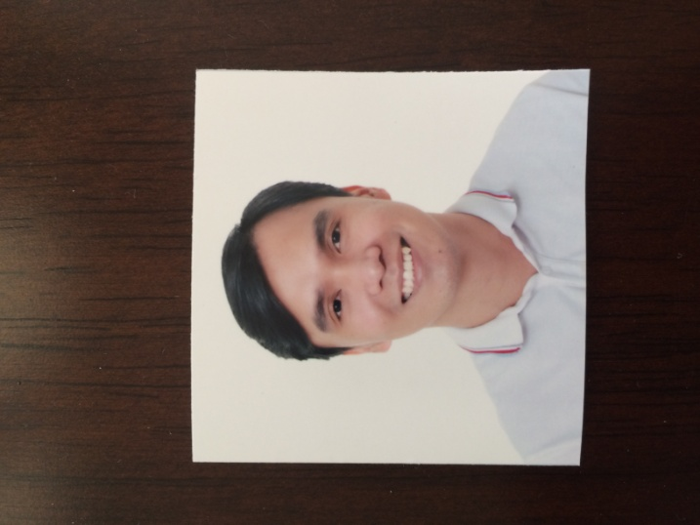
RAMJAY DELA CRUZ ESPAÑA, RN
Address: 298 GCR building EDSA cor. Sultan St.
Brgy. Highway Hills Mandaluyong City
Contact number: 09069795598
Email Address: ramjayespana30@gmail.com

OBJECTIVES: Seek to work in an environment that will challenge me further to utilize my learned skills and knowledge in nursing care, and extend a helping hand to this noble profession while contributing to the growth and success of the institution.

PERSONAL BACKGROUND:
Age: 32 years old
Birthdate: December 30, 1988
Birthplace: Jose Panganiban, Camarines Norte
Civil Status: Married
Religion: Roman Catholic
Nationality: Filipino
Spouse Name: Arianne Lou Aguilar España (Psychiatric Nurse)
Father’s Name: Ramton Nepomuceno España (Mechanical Engineer)
Mother’s Name: Aida Dela Cruz España (Housewife)

CIVIL SERVICE ELIGIBILITY:
Passed the November 2009 Philippine Nurse Licensure Exam
- PRC License No: 0623125
- Board Rating: 77.60%

EDUCATIONAL ATTAINMENT:

Tertiary Education: University Of Sto. Tomas – Legazpi City
- Formerly: Aquinas University
College of Nursing
Rawis, Legazpi City
Philippines
2005-2009

- Bachelor of Science in Nursing (Batch 2009)

Secondary Education: St. Raphael Academy
Legazpi City
Philippines
2001-2005

Elementary Education: Ibalon Central School
Legazpi City
Philippines
1998-2001

Elementary Education: Jose Panganiban Elementary School
Jose Panganiban, Camarines Norte
Philippines
1994-1998

MEMBERSHIP IN ORGANIZATION:

- National League of Philippine Government Nurses Inc.

- Philippine Nurses Association

- The Catholic Nurses Guild of the Philippines

TRAININGS, SEMINARS/VOLUNTARY EXPERIENCE:

December 18, 2017 Seminar and Workshop in Innovation Management: An introduction to the APEC Digital Hub for Mental Health
(National Center for Mental Health)

July 14, 2017 Nursing Consideration in Adverse Drug Reactions
(National Center for Mental Health)

April 30, 2016 Assessment of Mental Illness - Forensic Psychiatry Seminar (GLI Institute)

April 30, 2016 Forensic Psychiatry in Healthcare Setting - Forensic Psychiatry Seminar (GLI Institute)

April 30, 2016 Management of Mental Illness - Forensic Psychiatry Seminar (GLI Institute)

October 9-10, 2015 13th Alzheimer’s Disease and Related Disorders Annual Convention (Dementia Society of the Philippines and the
Allied Specialist Group)

August 30, 2015 Does it require Evidence-Based Practice? Research? Or Process Improvement? Designing and Applying the Right Strategy in Nursing (Integrative Nursing Research Society Philippines)
August 27, 2015 ASEAN Integration 2015 : It’s Impact on Nursing Practice (Associatoin of Nursing Service Administrators of the Philippines Inc.)

June 25-26, 2015 First ASEAN Patient Safety Congress (UP Medical Alumni Fund Inc)

May 9, 2015 Creating and Validating your Innovative Research Design(Integrative Nursing Research Society Philippines)

April 24, 2015 Psychological First Aid(Philippines Nurses Association Inc.)

March 27, 2015 Ecology in Healthcare: A challenge to Work-life Balance(Association of Nursing Service Administrators of the Philippines Inc)

November 19, 2013 Early Detection and Prevention of Suicide
(National Center for Mental Health)

September 6, 2013 “Compassionate Care of the Sick: Nurses Faith Alive”
(The Catholic Nurses Guild of the Philippines)

July 1-26, 2013 Mental Health & Psychiatric Nursing Course for RN HEALS IV In-Service Training (National Center for Mental Health)

April 17, 2013 “A Fight against Pneumonia”
(National Center for Mental Health)

October 5-6, 2012 10th Alzheimer’s disease and Related Disorders Annual Convention (Dementia Society of the Philippines and the
Allied Specialist Group)

September 23, 2012 Forensic Nursing – Examination of the Dead
(Global Learning Innovations Institute)

September 23, 2012 Forensic Nursing – Wound Assessment
(Global Learning Innovations Institute)

September 23, 2012 Forensic Nursing – Sexual Assault Examination
(Global Learning Innovations Institute)

February 23, 2012 Dealing with Abuse and Pregnancy-Related Trauma
(Pro-life Philippines Foundation, Inc. and Catholic Nurses’ Guild of the Philippines)

July 21, 2010 People’s Day a Monthly Outreach Program for Adult and Pediatric at Risk of Cardiovascular Diseases
(Philippine Heart Center)

May 22, 2010 Current Needs of Ethico-Moral Humanized Care
(The Catholic Nurses Guild of the Philippines)

SKILLS AND OTHER QUALIFICATIONS:

- A valid license holder of Registered Nurse (RN) with good academic records

- Efficient in standard nursing practices and procedures, medical terminologies, nursing policies, and hospital regulations.

- Strong organizational, interpersonal, analytical and communication skills.

- Undergone on the job trainings in different hospitals and clinics
(Manila & Provincial Areas)

- Computer Literate:

- Microsoft Office (Word, Excel, PowerPoint), Basic Troubleshooting, Network and Security Software.

- Good in oral and written English, Tagalog, Bicol (Dialect)

HOSPITAL WORK EXPERIENCE:

- December 15, 2014 up to Present --- STAFF NURSE (NURSE 1)
National Center for Mental Health
Nueve de Pebrero, Mandaluyong

- Areas of Assignment:

- Acute Psychiatric Ward (Male)
December 15, 2014 – June 30, 2015

- Sub Infirmary - Psychiatric Ward (Male)
July 31, 2015 - December 31, 2015

- Acute Crisis Intervention Section (Male)
January 1, 2016 – June 30, 2016

- Acute Psychiatric Ward (Male)
July 1, 2016 – up to present

Job Description:
- Providing patients with a safe, person-centered, secured environment where Individuals can receive the appropriate care and treatment required to manage their complex and long-term needs.
- Provides nursing care to patients, carries out physician’s orders, administers prescribed medication and treatments, prepares equipment and aids physician during treatment and examination, observes, records, and assess patient’s significant conditions and reactions, provides health teachings, takes temperature, pulse rate/cardiac rate, respiratory rate, and blood pressure.

Duties:
- Maintaining a safe and secure environment.
- Assessing the care needs of patients.
- Responsible for the custody, storage and administration of medicines.
- Development, implementation and evaluation of programs of care.
- Working with mental health service-users in a multi-professional setting.
- Looking after patients with severe and enduring mental illness.
- Performing administrative duties.
- Involved in the screening, assessment and follow up support of patients.
- Liaising with other health care professional and social workers.
- Reporting to senior managers.
- Maintaining a high standard of nursing care during procedures and treatment.

- January 7, 2013 up to December 31, 2013 --- NURSE (RN HEALS PROGRAM)
National Center for Mental Health
Nueve de Pebrero, Mandaluyong

- Areas of Assignment:

- Forensic Psychiatric Service – (Male)
January 7 – March 31, 2013

- Acute Psychiatric Ward (Male)
April 1 – June 30, 2013

- Rehabilitation Psychiatric Pay Ward (Male)
July 1 – September 30, 2013

- Sub Infirmary - TB Cottages Psychiatric Ward (Male)
October 1- December 31, 2013

- September 29, 2010 up to January 4, 2013 --- LIAISON OFFICER
(Medical Department)
Value Care Health Systems, Inc.
Health Maintenance Organization
Unit 607-613, 6th Floor
East Tower, PSEC Exchange Road
Ortigas Center, Pasig City.

Job Description:
- Assumes responsibility in handling client’s inquiries & concerns pertaining to their healthcare & medical insurance policy coverage.
- Perform other task assigned by immediate Supervisor such as relieves Clinic Nurse on leave, act as Nurse to companies on special events.
- Endorses correctly to accredited doctors, clinics & hospitals members for consultation or for any availment of benefit.
- Coordinates approval of complex & sophisticated cases, laboratory procedures & in patient diagnostic work-ups with Supervisors and Medical Director.
- Monitors effectively utilization & status of clients before approving coverage.
- In-charge of the issuance of correct outpatient approvals to accredited hospitals, clinics & dentists.
- Courteously & professionally addresses client’s complaints & refer at once to Supervisor other Matters that need further evaluation & management.
- Assist professional hospital liaison officers & relay correct coverage to admitted patients.
- Records accurately all daily incoming calls & provides the necessary details regarding status & management done to patient.
- Coordinates timely & effectively any surgical procedure with Supervisors and Medical Director.
- Coordinates w/ different departments of the company to satisfactorily address clients & brokers needs.

REFERENCES:

- Mr. Vicente B. Peralta, RN, MSN
Dean - College Of Nursing,
Aquinas University Rawis, Legazpi City
Cell. No.: 0917-813-1233
Tel. No: (052)-4820364

- Dr. Ronaldo V. Mendoza
Medical Director – Medical Department
Value Care Health Systems, Inc.
Ortigas Center, Pasig City
Cell. No: 0920-920-2350
Tel. No: (02) 702-3310 local 3316

- Mrs. Elizabeth Jose, RN, MAN
Supervisor - Pavilion 26 Male TB Cottage
National Center for Mental Health
Nueve de Pebrero, Mandaluyong City
Cell. No: 0919-619-3594
Tel. No: (02) 531-9001 local 329

I hereby certify that the information given are true and correct as to the best of my knowledge.

RAMJAY D. ESPAÑA, RN

