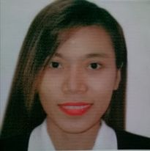
Address: Blk.30 Lot 14 Bistekville 2 Kaligayahan, CP No.: 09171857849
Irene Pablo Canceran
Licensed Professional Teacher
Registration Number-1481094

A tech-savvy, resourceful and hardworking teacher with exceptional ability in managing students. Offering my two (2) years of varied instructional experiences in the field of teaching and school works including online teaching. My pleasure to share beyond the call of duty.
Novaliches Quezon City Phillipines Email: irenecanceran28@gmail.com
Birthday: August 15, 1995 Facebook: https://www.facebook.com/irene.canceran.3
SKILLS
____________________________________________________________________________________________

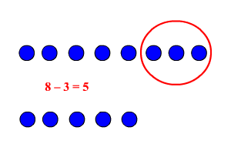
Positive Attitude towards work Microsoft office proficient

Flexible and perform the task with Ability to work under pressure
minimal supervision and time management
Enthusiastic Classroom Management Interactive and easily get along with others

Honest; Reliable; Willing to accept God-centered and God fearing individual
changes; Criticisms and challenges

WORK EXPERIENCE
___________________________________________________________________________________________
Substitute Teacher- Grade 1 (Distance Modular Learning)
Rosa L.Susano Novaliches Elementary School
10/2020-12/2020 Quirino Hi-way Gulod Novaliches, Quezon City
Achievement/Tasks
- Distributes and collects learning materials/modules
- Checking/recording children’s output

Teacher – Grades 1- 3 Adviser (Elementary Department)
Starland International School – Cubao Branch
06/2018 – 04/2020 #93 12th Ave. Cubao, Quezon City
Achievement/Tasks
- Creates worthwhile activites in learning the subject matter
with mastery
- Facilitates learning with enthusiasm and dedication
- Teach basic education curriculum
- Imposed discipline and importance of following rules
- Helps children develop socialization skills

Teacher – Grade 2 Adviser (Elementary Department)
Mount Charmel School of Achievers
09/2017 - 03/2018 No.789 Quirino Hi-way RP Gulod Novaliches QC
Achievement/Tasks
- Creates worthwhile activites in learning the subject matter
- Facilitates learning with enthusiasm and dedication
- Imposed discipline and importance of following rules
- Helps children develop socialization skills
EDUCATION
____________________________________________________________________________________________

Graduate Studies
Polythecnic University of the Philippines
04/2019 – 10/2019 Anonas St.,Sta.Mesa Manila
Master in Education Management – 12 units

Tertiary Level
Isabela State University – Cabagan Campus
06/2012 – 04/2016 Garita heights Cabagan, Isabela
- Bachelor of Elementary Education

Secondary Level
Santo Tomas National High School
06/2008 – 03/2012 Poblacion Santo Tomas, Isabela

Primary Level
Santo Tomas Central School
06/2002 – 03/2008 Poblacion Santo Tomas, Isabela

CERTIFICATES/TRAINING
______________________________________________________________________________________________________

ICT and Englishtek Training (parallel Session) How to maximize the Use of Science for
(07/2019) Active Learning Series (06/2019)
Starland International School Starland International School

Quality Service and Being Happy at Work and In-Service Training for Public School
Effective (06/2019) (12/2020)
Starland International School Rosa L. Susano Novaliches Elementary School

Classroom Management in the 21st Century Computer Literacy-Microsoft Application
(06/2019) (01/2018)
Starland International School Taberna Computer Workshop

Seminar Workshop on Detailed Lesson Plan Mind Education Specialist Training
(07/2019) (01/2018)
Starland International School International Youth Fellowship

REFERENCES
____________________________________________________________________________________________________

Imie C. Mallanao Elizabeth Cabaton
Teacher III – Rosa L. Susano Novaliches Elementary School Teacher – Holy Family School of Quezon City
Contact: 09361778421 Contact: 09167512936

Riamie Tadeo
Teacher I Krus na Ligas Elementary School
Contact: 09095403533

I hereby certify that the above information is true and correct to the best of my knowledge and belief.

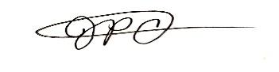

IRENE P. CANCERAN
applicant

