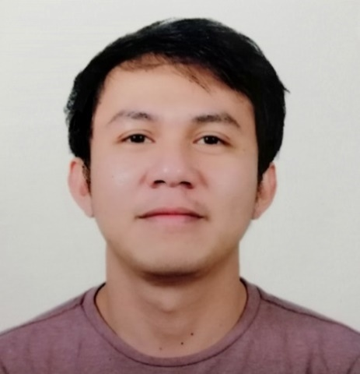

Ryan Mark B. Separis
PRK32 Mountain View Sialza Compound
Cabantian, Buhangin Dist, Davao City, Philippines, 8000
Mobile No. : (+63) 927-022-8722 / (+63) 926-570-7032
Email Add : ryanmarkseparis@gmail.com

KM11

PERSONAL INFORMATION

Permanent Address : Km.11 Prk.32 Mountain View Sialza Compound Cabantian,
Buhangin Dist, Davao City, Philippines, 8000
Birthdate : July 04, 1992
Birth Place : Tagum City
Height : 5’4 ft.
Weight : 56 kg
Sex : Male
Civil Status : Single
Religion : Jehova’s Witnesses
Nationality : Filipino

BENEFICIARY

Beneficiary Name : Separis, Merlyn Bacaron
Relationship : Mother
Permanent Address : Km.11 Prk.32 Mountain View Sialza Compound Cabantian,
Buhangin Dist, Davao City, Philippines, 8000
Cellphone No. : (+63) 915-477-7128

DEPENDENTS

Father: Separis, Oseas Narisma Birthday : November 01, 1956
Birth Place : Tagum City
Occupation : Driver

Mother: Separis, Merlyn Bacaron Birthday : July 30, 1961
Birth Place : Island Garden City of Samal
Occupation : Bag Maker

BROTHER/SISTER

Brother: Separis, Glenn Bacaron Birthday : February 20, 1983
Birth Place : Tagum City
Civil Status : Married
Occupation : Accountant at DepEd Panabo

Brother: Separis, Bladdy Bacaron Birthday : February 21, 1984
Birth Place : Tagum City
Civil Status : Married
Occupation : Deboner at JBS Rockhampton
Queensland Australia, 4701

Sister: Separis, Loudethzel Baracon Birthday : October 10, 1998
Birth Place : Tagum City
Civil Status : Single
Occupation : Accounting Staff at Suringa Law
And Accounting Office

EDUCATIONAL BACKGROUND

Tertiary : University of Mindanao
Matina Davao City, Philippines
Bachelor of Science in Accounting Technology
Year 2009-2012 ( Not completed )

Secondary : University of Mindanao Tagum College
Tagum City, Philippines
Year 2005-2009

Elementary : Rizal Elementary School 1
Sobrecary Street, Tagum City, Philippines
Year 1999-2005

EMPLOYMENT HISTORY

July 2009 - Present : Butcher/Slaughterman/Deboner
Irene Samonte Alcantara
Meat and Livestock Dealer
Stall No. 443 Meat Section, Tagum City Public Market
Tagum City, Davao del Norte, Philippines 8100
Contact no. 09389208064

Duties and Responsibilties
From Monday to Saturday (6:00 pm to 6:am)

▪ Perform multi-task every day(6pm-6am) in processing one (sometimes 2) live cattle into carcass like stunning, shackling, lifting, sticking, bleeding, cradling, flaying, eviscerating, splitting, quartering, trimming, weighing, stamping and deboning.

July 2017 – May 2018 : Deboner
Teys Australia Central QLD Pty. Ltd.

Duties and Responsibilities:
Every Weekdays having one rooster day-off
(6AM-4:50PM)

- Boning rump, knuckle, silverside, topside and shin.
- Participate in workplace communication.
- Perform occupational health and safety procedure.
- Apply food safety and sanitation.
- Implement environmental policies and procedures.
- Clean, sterilize, maintain and sharpen knives/tools/equipment

January 2009 – April 2012
October 2013 – June 2017 : Slaughterman/Slaughter Operator/Deboner
October 2018 – Present Tagum City Slaughterhouse

Duties and Responsibilities:
From Wednesday to Sunday (6:00PM-12AM)

- Cleaning the slaughter before working.
- Preparing personal protective equipment/materials for slaughtering activities.
- Unloading animals carefully to avoid stress and injuries.
- Animals are rested and off feed before slaughtering.
- Washing the animals prior to slaughter.
- Driving the animals to slaughter are slowly to avoid anxiety which may lead to stress.
- Stun animals using stunning gun.
- Shackling animals using appropriate shackling equipment in preparation to sticking.
- Sticking is done properly to avoid incomplete bleeding. Complete bleeding is obtained to produce good quality meat.
- Partial flaying. Removal of feet and head, hoisting, gambreling; final flaying is done properly to avoid carcass contamination.
- Eviscerations. Removal of the visceral organs.
- Splitting and quartering of the carcass using splitting saw.
- Washing the carcass to avoid any contamination using water.
- Weighing
- Dispatching.

TRAININGS & SEMINAR

Duration: April 20, 2012
Address: City Hall of Davao City
Title: Pre-employment Seminar for Local Applicants (PESLA)

Duration: January 23, 2014 to April 20, 2014
Training Center: LGU in partnership with TESDA
Address: Barangay East, Tagum City, Davao del Norte
Title: Slaughtering Operation

Duration: July 18,2017
Address: 5th Flr., UNLAD Condo., 1665 Gen. Malvar St. cor. Taft Ave., Malate, Manila
Title: Pre-Departure Orientation Seminar – Certificate No. 1602172

SPECIAL SKILLS/ INTERESTS

- Deboning
- Cooking
- Fishing
- Reading Books
- Agricultural Farming (Poultry Chickens)

CHARACTER REFERENCES

David Patrick Sakwa
Teys Australia Veterinarian
Contact no. 0458368640

Jemuel Lacap
Teys Deboner
Contact no. 0476309061

Leonardo G. Briones Jr.
Slaughterhouse Master IV
Slaughterhouse/TLAC Division
Contact no. 09267171459

Dr. Jesus Edullantes, DVM
Tagum City’s Chief Veterinarian
Contact no. 09275313456

I hereby certify that the above mentioned information is correct and true to the best of my knowledge and belief.

Ryan Mark B. Separis
Applicant

