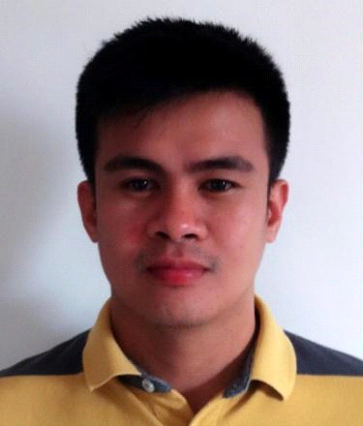

Harold Deoferio
Nueva Vizcaya, Philippines
+63926-900-8399
Skype ID: live:8d11aa4114d046b3
harolddeoferio2414@gmail.com

PROFESSIONAL SUMMARY

I come from a hard working background that will involve both school and work. Always having to be timely and ready to surpass any expectations given. Getting the job done on time and correct is what I believe to be the best pleasure at work. To me being introduced to a new job make me eager and excited because I’m always ready to learn, meet challenges and quickly assimilate new concept.

SKILLS

- Fast learner
- Highly dependable
- Excellent attention to detail
- Able to work under pressure
- Professionalism
- Multicultural sensitivity/Awareness
- Dedication/Hardworking
- Positive attitude/Energy
- Flexibility/Adaptability
- Ability to work in a team
- Friendly/outgoing personality
- Honesty/integrity
- Reliable/responsibility

CERTIFICATION

Basic Beekeeping Training
Saint Louis University – Extension Institute for Small Scale Industries Foundation Inc.
April 20-22, 2021

Advanced Beekeeping Training
Saint Louis University – Extension Institute for Small Scale Industries Foundation Inc.
April 27-29, 2021

WORK EXPERIENCE
Technical Support
AT&T
Sitel Philippines

Handled networking and DSL connection issues.
Key Accomplishments:
- Managed a high-volume workload within a deadline-driven environment. Consistently met performance benchmarks in all areas (speed, accuracy, volume).
- Helped the company attain the highest customer service ratings (as determined by external auditors) -- earned 100% marks in all categories including communication skills, listening skills, problem resolution and politeness.
- Officially commended for initiative, enthusiasm, tenacity, persuasiveness, intense customer focus and dependability in performance evaluations.
- Completed voluntary customer service training to learn ways to enhance customer satisfaction and improve productivity.

Customer Service Representative
Direct TV
Convergys
Handled customer inquiries regarding billing and performed basic troubleshooting.
Key Accomplishments:

- Respond to questions and concerns regarding billing.
- Handled quality assurance and review of billing activities.
- Consistently improve customer satisfaction through complete resolution of issues and concerns.

Department Head
ABC360 Philippines

Key Accomplishments:
- Facilitate trainings
- Payroll endorsement
- Schedule management

Social Media Support
LULU cartoons co

- Respond to Direct Messages via Gorgias
- Respond to Facebook and Instagram comments via Gorgias
- Manage company reviews on Stamped.io and Productreview.com
- Schedule Instagram story via Skedsocial.com
- Prepare and do product marketing via Twitter deck and Instagram
- Prepare product posting for Facebook

Email Customer Support & Facebook Moderator
Nexxus Deals

- Handled emails via Zendesk
- Respond to all queries
- Manage cancellations and returns
- Moderate Facebook account

Email Customer Support –Team lead
APR Ecommerce
- Handled emails via Gorgias
- Fulfilled orders in Shopify
- Managed and trained members of the CSR team.
- Coordinates with suppliers
- CRM management

EDUCATION
Bachelor of Science in Computer Engineering
University of Baguio
2001-2002

Bachelor of Science in Nursing
University of Baguio
2003-2006

