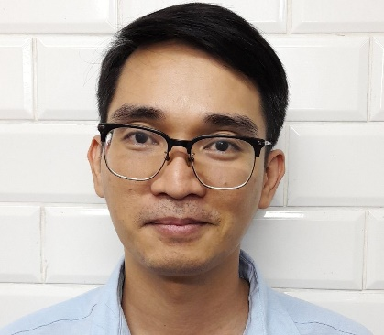
John Bonne U. Palmera
Contact no. 63961- 346- 8365/ 639770877893
Lot 1 Block 34 Taurus St. San Roque Navotas City, Philippines
bonpalmera@gmail.com

Work Experiences
Burger King Balanga Bataan
April 16 2021- present
Shift Manager

Tendon Kohaku
May 3, 2018 – February 28,2021
Store Supervisor

Job Description
- Oversees overall staff and store operations.
- Prepares Payroll, Service charge computation, schedule of Dining and Kitchen staffs.
- Teaches staff proper standards in Japanese hospitality

Dohtonbori Okonomiyaki
August 1, 2017-March 12, 2018

Chibo Okonomiyaki
May 24, 2016-April 5, 2017
Captain Waiter

Magsaysay Maritime Corporation
Steward – C, Waiter, Bar Waiter
May26, 2010 –July 4, 2013

Education
College (Bachelor of Science in Hotel and Restaurant Management)
Bataan Peninsula State University 2005 – 2009
High School
Bataan Polytechnic State College 2001 – 2004
Skills
-Proficient in MS excel and word.
- Able to speak service oriented Japanese and fluent in English
- Accustomed to certain Japanese culture.

Personal Information
Age: 33 yrs old
Height: 5’9”
Weight: 67 kilos

Character Reference

Elvira Flor
Store Supervisor
0998-450-0116

Marilen Soriano
MOPAS Fleet Manager
0999-512-9693

Alexander Orge
Restaurant Manager (Chibo)
898-3333/0975-065-9243

