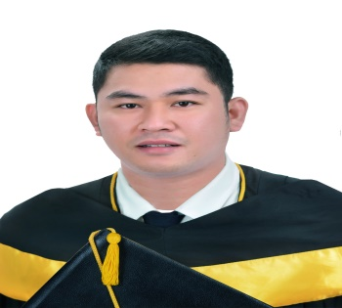
ISRAEL DENOY
99 Ems St Linotype Fourth Estate San Antonio Paranaque 09270164199
09989019386
iamisraeldenoy@yahoo.com

CAREER OBJECTIVE

To become an excellent team member in a reputable and career oriented industry where I can showcase my expertise and skills which helps for my career advancement.

PERSONAL INFORMATION

Age: 34 years old
Birthdate: May 15, 1986
Birthplace: Tabango, Leyte
Religion: Roman Catholic
Citizenship: Filipino
Civil status: Single
Sex: Male
Height: 164cm.
Weight: 150 lbs.
Mother’s name: Mrs. Leopolda Denoy Serilles
Occupation: Sari-sari store owner

EDUCATIONAL ATTAINMENT

Tertiary: Bachelor of Science in Industrial Technology
College: Biliran Province State University, Naval, Biliran
Course: Food Technology
Year Graduated: 2018-2019
Secondary: Leyte Agro Industrial School Leyte, leyte
Year Graduated: 2006-2007

SKILLS AND QUALIFICATION

- Excellent communication.
- Proficiency in commercial cooking.
- Has a basic knowledge in baking and pastry.
- Computer Literate.
- Impeccable teamwork.
- Good human relation.
- Good Statistical background.

CERTIFICATE

- National Certificate II (NCII) in cookery. (TESDA)
- Food Technologist of the year.
- Integrated Food Safety System (Food Hygiene)

EMPLOYMENT HISTORY

Kitchen Staff/Line Cook
KIWA KOREAN GRILL AND RESTAURANT
Solaire Resort and Casino
Aseana city, Parañaque City
May 2019-present

Duties and responsibilities
- Consistently follow Head chef's work related instructions.
- Provide excellent service and being into details.
- Ensures that kitchen utensils/equipments are cleaned and sanitize beforea and after use.
- Production various food items for a day to day use.
- Proper hygiene is highly practice before handling food items.
- Cook foods according to recipe and kitchen protocol.
- Maintain an exceptional service for costumers satisfaction.
- Play as a good team player and be professional towards colleagues.

ON-THE- JOB TRAINING (OJT) ( May 3, 2018-February 3, 2019)

- MARU KOREAN RESTAURANT(400hrs/2months)
- MAIN HOT KITCHEN (1400hrs/7months)
JPark Island Resort and Waterpark, Mactan Cebu (5 star hotel)
Tel No. +63324945000
Manuel L.Quezon Highway Maribago, Lapu-Lapu City Cebu,Philippines.
.

CHARACTER REFERENCES

Available upon request

