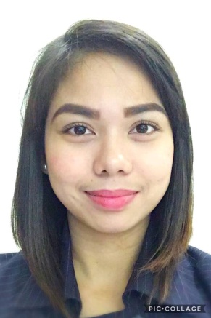
Roxanne Mae M. Salome
________________________________________________________________________
51 P.Cruz St. Barangka Ibaba
Mandaluyong City
09233587951
rmsalome@gmail.com

Career Objectives
An experienced and well maintained professional having ample amount of knowledge in banking sector and seeking an opportunity in the organization to use my skills and be able to contribute to the firm for which I am working. I will put my best effort to learn the company's policies and make better decisions in the favour of the company.

Career Summary
- Having 8years of experience in the field of banking.
- Providing solutions to the customer’s problem.
- Selling bank product's to the customers and giving them after sales services.
- Providing banking solutions to the rising needs of the customers.

Computer Skills
- Good knowledge of managementn software and usage of its tools.
- Knowledge with Microsoft office kit – MS Excel, MS Word, Power Point, and excel.

Professional Experience
Marketing Assistant(2013-Present).
BDO Unibank Inc.
- Carry out day-to-day administrative tasks.
- Relying heavily on computer knowledge.
- Sellimg bank product's to customers.
- Responsible to deal with investments and new accounts everyday.
- Ability to multi-task.

Educational Qualification

- Rizal Technological University, 2013.
- Arellano University Plaridel High School, 2009.

Personal details

Date of Birth: April 19, 1992
Language known: English
Nationality: Filipino

