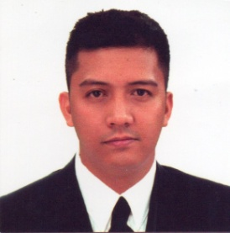
MARVIN MADELA CALALANG
Address : Blk 43 Lot 7 Escopa 3 Project 4 Quezon City
Mobile Number : 0945-4414-307

Personal Information :

Nick Name : meng
Birth Date : June 16, 1990
Age : 30
Religion : Roman Catholic

Educational Background :

Miriam College
Quezon City
Food and Bevearages Service
2010 - 2011

Jose P. Laurel Sr High School
Salalila St. Project 4, Quezon City
2004 – 2008

Pura V Kalaw Elementary School
Salila St Project 4, Quezon City
2000 - 2004

Working Experiences :

Happy Wings and Waffles
Intramuros Manila
Kitchen Staff
Dec. 2017 - Feb. 2020

Shang –rila Hotel and Resorts The Fort
Taguig City
Kitchen Steward
March 2016 – November 2016

Antel Hotel
Makati City
Banquet Waiter ( On Call )
May 2015 March 2016

Raffles and Fairmont Hotel
Makati City
Kitchen Steward
October 2013 May 2014

Linden Suitess Hotel
Pasig City
Banquet Waiter
June 2010 March 2012

Jollibee Food Corp.
Ali Mall Cubao Quezon City
Stockman
October 2009 April 2010

Character Refferences :

Mr. Danton Remoto
English Professor
Xavier ville. St. Katipunan Qc

Mr. Victor Bejar
Brgy. Kagawad
137 A. De Legaspi St. Proj. 4 Qc

_____________________
Marvin Calalang

