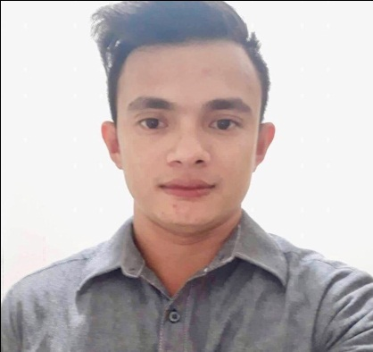
JOSEPH RELAMPAGOS CAMPOAMOR
Present Address: Nivel Hills Lahug, Cebu City
Philippines: Cebu City
Mobile number: +639281824644
Email: Josephcampoamor23@gmail.com

PERSONAL INFORMATION
Permanent Address: Lahug, Cebu City, Philippines
Birthdate: December 10, 1991
Birth Place: San Miguel, Bohol, Philippines
Height: 5’6
Weight: 63kg
Sex: Male
Civil Status: Single
Religion: Roman Catholic
Nationality: Filipino

BENEFICIARY
Beneficiary Name: Cirila Campoamor
Relationship: mother
Permanent Address: Kagawasan, San Miguel, Bohol
Tel. No: 639090976575

DEPENDENTS:
Father: Bartolome Campoamor Birthday: August 24, 1957
Birth Place: Loon Bohol
Occupation: Farmer

Mother: Cirila Campoamor Birthday: August 1, 1956
Birth Place: San Miguel Bohol
Occupation: Housewife

CHILDREN

Daughter: Birthday:
Birth Place:
Civil Status:
Occupation:

Sister: Nancy Campoamor Genita Birthday: October 4,1983
Birth Place: San Miguel, Bohol, Philippines
Civil Status: Married
Occupation: House Wife

EDUCATIONAL BACKGROUND

Elementary Year
(From) – (To)
School: Kagawasan Elementary School 1999-2004
Address: Kagawasan San Miguel Bohol
Secondary
School: Mahayag National High School 2004-2008
Address: Mahayag San Miguel Bohol
College
Course: Bachelors of Science in Industrial Technology( major in electrical technology)
School: Cebu Technological University
Address: M.J Cuenco Ave. Cebu City

EMPLOYMENT HISTORY

Position: Department Manager
Company: Golden Arches Development Corporation ( McDonalds Philippines)
Address: Lapu Lapu City , Cebu
Date: March 16, 2015 to present
Reason for Leaving: Seeking for better opportunities and its my dream to work in Canada as well as an immigrant.

Job Description / Duties and Responsibilities:
Food Quality Manager
Responsibilities
- Inspect facilities for compliance with hygiene Standards and determining methods to resolve in issues that arise
- Review Customers Feedbacks and respond to any complaints
- Reports on food quality standard to be presented to management and may keep records of all test and inspections that have been conducted
- Ensuring that food products and processed finished goods meet standards set by the company
- Order HAVI web and Local deliveries
- Produce P&L report to Restaurant General Manager
- Production Manager
- Service Manager
- Shift Leader
- Pollution Control Officer
- Safety and Security Officer

SPECIAL SKILLS / INTERESTS
SPECIAL SKILLS INTERESTS
Great Leadership Volunteer work
Active Listening Club membership
Communication Skills Traveling,fishing
Ability to work under pressure Sports
Can work with passion Art,music (playing,listening)
Costumer Service Experience Job related Activities
Interpersonal Skills

CHARACTER REFERENCES

EMERSON MARIMON
Civil Engineer
Senior Site Project Engineer
APBS/HRDB Maamunagau Resort Project Maldives.
+960 7850480

DANNY ECONAS
Civil Engineer
Senior Consultant Philippines

ALFIE DWIGHT MIRANDA SY
Food Restaurant Supervisor
Tim Hortons
British Columbia,

