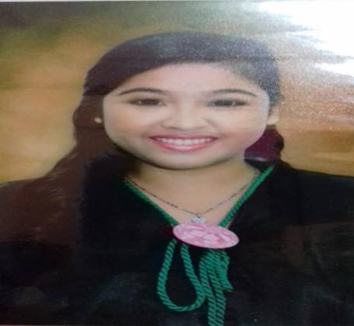
JEDDALYN U. ARELLANO

Zone2 Mendoza Comp. Patag CDO
Mobile # : 09678914421
Email ADD : arellanojeddalyn705@gmail.com

CAREER OBJECTIVE
To Obtain a career in any hotel and cruises where I can utilize my passion and skills with my creativity and expertise in the field of cruise ship management

EDUCATIONAL ATTAINTMENT

Tertiary
Lourdes College 2014-2016
Capistrano Hayes St. Cagayan de Oro City
ASSOCIATE in HOTEL and RESTAURANT MANAGEMENT

SECONDARY
Golden Heritage Polytechnic College 2010-2014
Vamenta Blvd. Carmen , Cagayan de Oro City

PRIMARY
Macanhan Elementary School 2009-2010
Carmen , Cagayan de Oro City

PERSONAL INFORMATION

Date of Birth : February 09, 1998
Place of Birth : La Union Bataan
Status : Single
Laguage : Filiipino , Cebuano , English

SKILLS
Business management skills
Decesion making skills
Excellence Personal Communication skills
Planning and organizing
Project Management skills: Influencing , Leading , negotiating and delegating abilities table skirting , bed set up

ON THE JOB TRAINING

DYNASTY COURT HOTEL
Food and Beverage , Housekeeping and Kitchen Staff
November 2015 – March 2016

LOURDES COLLEGE
Receptionist and Housekeeping
August 2015 – November 2015

WORK EXPERIENCE

HOTEL RAMON
RECEPTIONIST
AUGUST 2016 – JANUARY 2017

CASA AZUCENA
RECEPTIONIST
FEBRUARY 2017 – AUGUST 2017

MAXANDREA HOTEL
RECEPTIONIST
SEPTEMBER 2017- FEBRUARY 2018

DEPARTMENT OF LABOR AND EMPLOYMENT
GOVERNMENT INTERNSHIP PROGRAM (RECEIVING/PAYROLL)
JULY 2018 – APRIL 2019

REGIONAL TRIPARTITE WAGES AND PRODUCTIVITY BOARDS
GOVERNMENT INTERNSHIP PROGRAM (PAYROLL)
APRIL 2019 - JULY 2019

3ME BLUESUN
CHECKER DELIVERY
AUGUST 2029 – OCTOBER 2019

AMERICANA COMPANY BENCHSTONE (DUBAI-UAE)
CASHIER/DISPATCHER
OCTOBER 2019 – OCTOBER 2020

TRAINING ATTENDEND

BAR CASHIER
River View
August 2017

BARISTA NCII BASIC TRAINING (NCII PASSER)
JAMAICAN
JUNE 6-17 , 2016

SEC MARITIME BASIC TRAINING
Bulua , Cagayan de Oro City
April 6-16 , 2018

SHIP SECURITY AWARENESS TRAINING AND SEAFARERS WITH DESIGNATED SECURITY DUTIES
Capitol University, Cagayan de Oro City
April 26, 2018

Service Quality for Key Employment Generation (SQ-KEGs)Creating Error-Free Services
Alae, Manolo Fortich, Bukidnon
May 7, 2019

2019 PRODUCTIVITY OLYMPICS REGIONAL WINNER
PEARLMONT HOTEL , CAGAYAN de ORO CITY
MAY 31, 2019

7s of Good Housekeeping
DTI Provincial Office Tiano Brothers St, CDO
June 10, 2019

Employees CompensationProgram
Deluxe Hotel
June 19. 2019

WORLD DAY FOR SAFETY AND HEALTH AT WORK 2019
3rd Floor Trinidad Bldg.
April 29, 2019

SHARJAH FOOD SAFETY PROGRAM
UNITED ARAB EMIRATES-SHARJAH GOVERNMENT (SHARJAH CITY MUNICIPALITY)
JULY 29, 2020

I hereby Certify that the above information is true and correct to the best of my knowledge and belief.

JEDDALYN U. ARELLANO
09678914421
arellanojeddalyn705@gmil.com

SIR/MA’AM

Being given to understand that there is vacancy for any position that suits my skills, please consider me as applicant for the position.

I request your good office to give me an opportunity to approve my capability in your organization. I assure you that I shall give my best in getting the jobs accomplished enclosed is my resume for your kind perusal

Expecting a Favorable response from your end

Thank you very much

Respectfully yours

Jeddalyn U. Arellano

