Name of the Participant:  (as appears on the passport) | Mary Cris P. Daduros
Street Address, City, Country: | Brgy. San Matias Dingle, Iloilo, Philippines
Telephone number: | 09465947428
Email Address, Skype: | dadurosmarycris@gmail.com
Date of Birth: | June 3, 1997

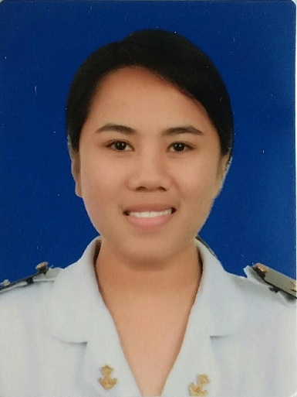

Other Languages: | Tagalog, English
English Ability | Fluent
Have you ever visited the United States: | No
Have you ever worked in the United States? | No
Do you have a driver’s license? | No
Hobbies: | Cooking, Cleaning, Traveling, Reading and watching motivational stories.
PROFESSIONAL EXPERIENCE 1
Company: | Mr. Misono ( Japanese Restaurant)
Job Title: | Dining Assistant
City, Country: | Iloilo City, Philippines
Dates: | January 13, 2017 – February 15, 2017
Brief Description of Task and Responsibilities:
PROFESSIONAL EXPERIENCE 2
Company: | District 21 Hotel
Job Title: | Kitchen Assistant
City, Country: | Iloilo City, Philippines
Dates: | January 15, 2018 – February 18, 2018
Brief Description of Task and Responsibilities:
PROFESSIONAL EXPERIENCE 3
Company: | Omni Orlando Resort
Job Title: | Cook II
City, Country: | Champions Gate, Florida
Dates: | December 10, 2018-December 9,2019
Brief Description of Task and Responsibilities: | Organizing equipments, ordering stocks, yielding of recipes and following direct orders from the Head Chef. Cooking ordered foods for large numbered events.

