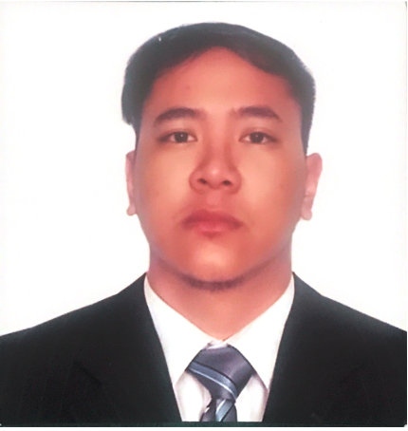
MELVIN O. VILCHEZ
4049 Masagana st. Dau Mabalacat City, Pampanga
August 02, 1996
0995-571-7319
0961-075-0545
vilchezmelvin@gmail.com

CAREER OBJECTIVES
I want to succeed in a stimulating and challenging environment, building the success of the company while I experience advancement opportunities.
EDUCATIONAL BACKGROUND
UNIVERSITY OF THE EAST-MANILA (2013-2018)
Bachelor of Science in Civil Engineering
College Diploma

Secondary Education (2009-2013)
DON BOSCO ACADEMY, PAMPANGA
Highschool Diploma

Primary Education (2003-2009)
SCHOOL OF THE INFANT JESUS, PAMPANGA
Elementary Diploma

WORKING EXPERIENCE

Trainee or Intern
RBRA ENGINEERS/MANAGERS & CONSULTANT
(Summer 2017 for 200 hours)
Work Experience
First Multi – Tech Industrial and Development Corporation (FMIDC)
(2020 – 2021)

SEMINARS AND TRAININGS ATTENDED

- Civil Engineering Specialization Congress 2016: Revolutionized (November 2016)
De La Salle University
- National Civil Engineering Symposium (September 2016)
University of the Philippines – Diliman
- Red Alert (July 2016)

SKILLS

Mathematical Skills
Good Inter-personal Skills
Strong Leadership Skills (UE-ACES officer)
ComputerLiteracy Skills (MS Office Applications; Computer Aided Drafting)

