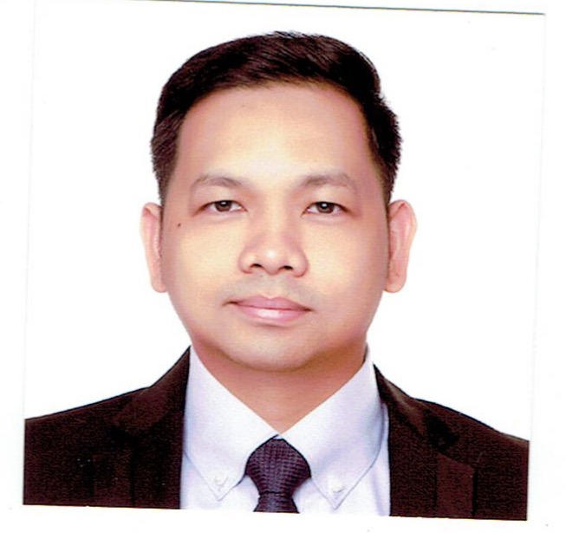

Attach Here
2x2
Colored Picture
Warren Roque Enverga
Block 6 Lot 9 Glenmont Subd., Sauyo Road, Novaliches, Quezon City
Philippines, 1116
Mobile No.: (63 )917-5076198
Email Add: wynenverga@gmail.com

PERSONAL INFORMATION

Permanent Address : Block 6 Lot 9 Glenmont Subd. Sauyo Road, Novaliches, Quezon City, Philippines, 1116
Birthdate : March 9, 1981
Birth Place : Mandaluyong City
Height : 5’7 ft.
Weight : 170 lbs.
Sex : Male
Civil Status : Married
Religion : Roman Catholic
Nationality : Filipino

BENEFICIARY

Beneficiary Name : Karmeer Grace Vengua Enverga
Relationship : Spouse
Permanent Address : Block6 Lot9 Glenmont Subd. Sauyo Road, Novaliches, Quezon City, Philippines 1116
Mobile. No. : (63) 917-8734286

DEPENDENTS:

Father: Enverga, Felizardo Imperial Birthday: August 14, 1946
Birth Place: Libon, Albay
Occupation: Driver
Mother: Enverga, Leonora Roque Birthday: June 21, 1953
Birth Place: Iligan City
Occupation: Housewife

BROTHERS / SISTERS

Brother: Enverga, Wilson Roque Birthday: March 19, 1979
Birth Place: Aurora, Cubao
Civil Status: Married
Occupation: Technician

Sister: Enverga, Kristine Roque Birthday: February 18, 1982
Birth Place: Sta. Mesa, Manila
Civil Status: Single
Occupation: Data Analyst

EDUCATIONAL BACKGROUND

Elementary Year [From] - [To]
School: Bagong Silang Elementary School 1988 - 1994
Address: Bagong Silang Caloocan City

Secondary
School: Metro Manila College 1994 - 1998
Address: Novaliches, Quezon City

College
Course: Electronics & Computer Technology 1998 - 2000
School: Asian College of Science and Technology
Address: Novaliches, Quezon City

EMPLOYMENT HISTORY

Position: Restaurant Manager
Company: Gotobox
Address: Marikina City, Philippines
Date: January 25, 2021 (Job Order Agreement)

Job Description / Duties and Responsibilities:
- Oversee all front and back of the Restaurant operations
- Ensure customers satisfaction through excellent services; respond to customer complaints tactfully and professionally
- Maintain quality control for all food served
- Analyze staff evaluations and feedback to improve the customers experience
- Oversee health code compliance and sanitation standards
- Projects future needs for goods, kitchen supplies and cleaning products and order accordingly
- Seek ways to cut wastes and decrease operational costs
- Train new employees and provide on going trainings for all staff
- Motivate the sales team to meet the sales objective by training and mentoring them.

Position: Server/Supervisor/Restaurant Manager-OIC
Company: Italiannis Restaurant
Address: Trinoma Mall, Quezon City, Philippines
Date: November 2004 – August 2020
Reason for Leaving: Resigned

Job Description / Duties and Responsibilities:
- Working with Director for Officer, develop the restaurant’s annual operating budget and control all profit and loss centers, including food, beverage, supply, utility and labor costs.
- Ensure safe working environment to reduce the risk of injury and accidents through continual repair and maintenance of restaurant
- Maintain an accurate and up-to-date manpower plan of restaurant staffing needs. Prepare management schedules and ensure that the restaurant is staffed for all shift
- Staff, train and develop restaurant managers and hourly employees through orientations, ongoing feedback, establishment of performance expectations and by conducting performance reviews.
- Responsible in maintaining an A Plus service to the guests by means of enhancing guests relation through serving high quality product in a fast and efficient service and making the guest feel at home.

Position: Server/Waiter/Bartender
Company: Ratstky Bar and Restaurant
Address: Tomas Morato St., Timog Avenue, Quezon city
Date: August 2003 – August 2004
Reason for Leaving: Resigned

Job Description / Duties and Responsibilities:
- In charge of order taking and delivering of food in a very friendly, fast and efficient manner without sacrificing the quality of food
- A constant top seller in terms of suggestive selling of wine and other alcoholic beverages which is one of the top contributors to the bar sales.

TRAININGS / SEMINARS ATTENDED

Training Center: The Bistro Group Duration: April 21, 2015
Address: 9727 Kamagong St., Brgy. San Antonio Village, Makati City, Philippines
Title: Train the Trainer

Training Center: The Bistro Group Duration: April 06, 2016
Address: 9727 Kamagong St., Brgy. San Antonio Village, Makati City, Philippines
Title: Coaching Skill Workshop

Training Center: The Bistro Group Duration: July 08, 2019
Address: 9727 Kamagong St., Brgy. San Antonio Village, Makati City, Philippines
Title: Leadershape

Training Center: The Bistro Group Duration: January 28, 2020
Address: 9727 Kamagong St., Brgy. San Antonio Village, Makati City, Philippines
Title: Store visit

SPECIAL SKILLS / INTERESTS

- Skilled in food preparation of Filipino and Italian dishes
- Driving skill and Carpentry
- Well-versed in oral and written English and Filipino.
- Hiking mountains

CHARACTER REFERENCES

Ms. Mary Ann Santiago
Director for Operation
Italiannis Philippines
Tel. No.: (63) 0915-3915567

Ms. Thess Alejandrino
Director for Operation
The Bistro Group
Tel No.: (63) 0917- 8274651

_________________________
Applicant’s Signature

