JUGIE D.CANDOL
Tabtuy, Tuyan ,City of Naga
09275855631
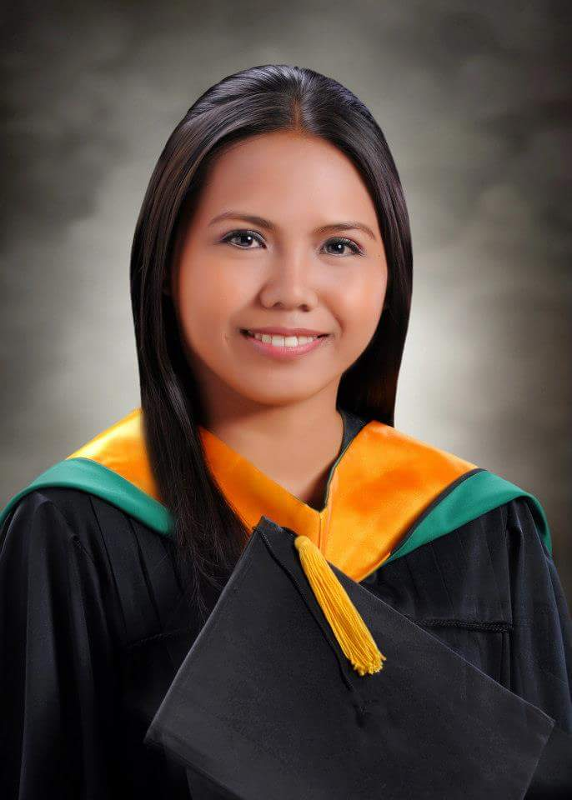
Email : degracia_jugie@yahoo.com

OBJECTIVE:To work in a company/health care facilities which enables me to apply my skills and knowledge to fits my qualification and i would like also to gain more experience and trainings that will help me for future career opportunities.

PERSONAL DATA:
Age : 31
Place Of Birth :Toledo City Hospital
Date Of Birth :April 21,1990
Sex : Female
Height : 5
Weight : 57 kg.
Civil Status : Married
Citizenship : Filipino
Religion : Roman Catholic

EDUCATIONAL BACKGROUND:

VOCATIONAL : Fil-Canadian Training and Development Center for Caregiver
Osmena Blvd., Cebu City
July 26,2013- March 14,2014

Culinary Arts Leading to Commercial Cooking
School:TESDA Skills Development Center
2011 Summer

TERTIARY : Bachelor of Science in Airline Management(BSAMGT
School:Cebu Aeronautical Technical School
2010-2013

Bachelor of Science in Nursing(BSN) Undergrad.
School:University of San Carlos

2006-2010

SECONDARY : Immaculate Heart of Mary Academy
Minglanilla,Cebu City
2002-2006

PRIMARY : Tuyan Central School
Tuyan,Naga City
1996-2002

LICENSES/EXAMINATION CERTIFICATES
- NC ll Caregiving Exam
June 2,2014
Center for Healthcare Professions Inc.
FCB Financial Center,AC Cortes Ave,Alang-Alang,Mandaue City
Remark:PASSED

- NC ll HEALTHCARE Exam
July 4,2014
Center for Healthcare Professions Inc.
FCB Financial Center,AC Cortes Ave,Alang-Alang,Mandaue City
Remark:PASSED

OJT EXPERIENCE:

- Daughters of Saint Camillus for Elderly Home
Talamban,San Jose Cebu City
March 31-April 21 2014

- My Bonita Home for Girls
Talamban ,San Jose Cebu City
April 23-May 13 2014

* Lufthansa Technik Philippines
Under line maintenance southern phil.
-Encoder
lapu lapu cebu
April10,2012-May 12, 2012

TRAINING

*Basic Life Support And First Aid
Filcanadian training and development centers to Caregiver
Month of October 14, 2014-December 2, 2014

*Basic Life Support Training
Emergency Rescue Unit foundation
. Conducted November 27,2015
At South General Hospital City of Naga Cebu

WORK EXPERIENCE

*Private Caregiver of diabetic pt.with right leg amputee
July 15,2014 - August 15 2014

*NURSING AIDE
South General Hospital
October 2015- present

JOB DESCRIPTION

*Assist in patients admission
*Accompanies patient to designated room/bed.
*Assist other activities directly concerned with patient care.
*Taking Vital sign such as BP/TEMP/RR,PR
*Help in Giving complete sponge bath esp.bedridden pt.
*Helping changing linen and also diaper
*Help transport patient to bed,stretcher or wheelchair
*Assist in CPR during code time, and do ambubagging
*Record every details patients do,also impotant things is the intake and output of.pt.

CHARACTER REFERENCES:

1. Engr.Carl vir Amabao
School Registrar
Cebu Aeronautical Technical School
Salinas Drive Lahug Cebu City
0322330097
2. Dr.Ronald Jarvik A.Buscato
Medical officer III
Department of Health
Region 7 Cebu City
. 09171666187

3.Jocelyn G.Garcia
Operator Manager
Fil-Canadian Training and Development Centers for Caregiver
Osmena blvd.Cebu City
09231211888

