MA. TERISCIEL JEFFER MANZO
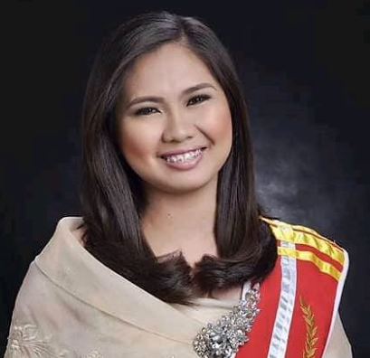 | BLK 40 Lot 38 Ph7 Carissa Homes Punta1 Tanza, Cavite  +639356065244  mtjvmanzo@gmail.com

Objective
To obtain a position that will enable to use my strong organizational skills, educational background and ability to work well with people and can utilize my expertise in airline industry.

Education

Lyceum of the Philippines University-Cavite Campus
2012-2016
Bachelor of Science in International Travel and Tourism Management

American Hospitality Academy
March 2014
Online Certificate Program

experience

CRO Lead Agent | MacroAsia Airport Services Corp.
March 2019 – Present
-Customer Relations Officer, Transfer Desk Agent, Check-In Counter Agent, Officer in Charge at the gate

Passenger Service Agent | MacroAsia Airport Services Corp.
October 2016 – February 2019
-Customer Relations Officer, Transfer Desk Agent, Check-In Counter Agent, Boarding Gate Agent and Arrival Agent

Admin Assistant-Training Department | MacroAsia Airport Service Corp.
April 2016 – October 2016
-Monitor the trainings of the agents, scheduled trainings, prepare all needed in training and update all information of the agents

On The Job Trainee | MacroAsia Airport Service Corp.
October 2016 – February 2016
- I assigned as Receptionist in Officce of the General Manager of the company and I transferred to Operations under Japan Airlines as a Trainee like a Passenger Service Agent

Skills & Abilities
- Strong Customer Service
- Knowledge in Sabre System and Althea System
- Complete Trainings in Airport Handling
- Background in airport ground handling and cabin preparation
- Strong Decision Making and Problem Solving

trainings
- PSS Sabre System Training
- Althea System Training
- PAL Security Awareness Training
- Dangerous Goods Cat.9 Training
- PAL Safety Management System Training
- PAL Human Factors Training
- US, AUS and UK Documents Training

References

Reynaldo Garcia, Airport Service Manager of Philippine Airlines
NAIA Terminal 2 Pasay City, +63 02 855 8000 loc. 7477

Emerson Bonoan Jr., General Manager of MacroAsia Airport Services Corp.
Paranaque City, +63 9175366113/+63 02 879 5886

MA. TERISCIEL JEFFER MANZO
Applicant

