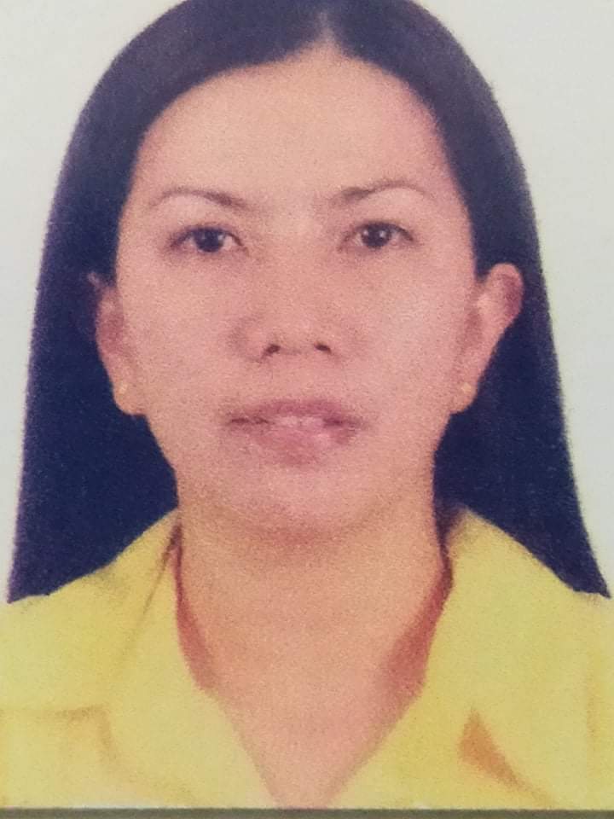

KAREN M. DIWA
Barangay Sibuan-Otong
City of San Fernando, La Union
Email Address: kmagsipoc@yahoo.com
Cell. No. (+63) 9271632782

A.PERSONAL DATA

AGE: 39 years old
PLACE OF BIRTH: San Fernando City, La Union
DATE OF BIRTH: May 29, 1982
CIVIL STATUS: Married
RELIGION: Pentecost
DIALECT SPOKEN: English, Tagalog, and Ilocano

B. EDUCATIONAL BACKGROUND

SECONDARY (1994-1998)
BASA AIR BASE NATIONAL HIGH SCHOOL
Basa Air Base, Floridablanca, Pampanga

ELEMENTARY (1989-1994)
BASA AIR BASE ELEMENTARY SCHOOL
Basa Air Base, Floridablanca, Pampanga

C. SKILLS AND QUALIFICATIONS
- Can work under pressure
- Consistently complete tasks on time or ahead of schedule
- Adapt well to changing requirements and information
- Punctual

D. WORK EXPERIENCE
OFW
2012-2014 HONGKONG
Branch Cashier
Palawan Pawnshop Palawan Express Pera Padala
Barangay Carlatan, City of San Fernando, La Union
February 17, 2017- present

E. PARTICIPATED AND ATTENDED SEMINARS

“Anti-Money Laundering Act”
August 9, 2019
Bangko Sentral ng Pilipinas, City of San Fernando City, La Union

F. CHARACTER REFERENCES

Reymarc G. Gacayan
Branch Manager
Palawan Pawnshop Palawan Express Pera Padala
Barangay III, City of San Fernando, La Union
09565142674

Vergielou C. Valdez
Branch Manager
Palawan Pawnshop Palawan Express Pera Padala
Balaoan,La Union
09455975105
Michael Ducusin
Nurse
Ilocos Training Regional Medical Center

I hereby certify that all facts contained in this form are true and correct to the best of my knowledge.

KAREN M. DIWA

