VICENTE B. PEPITO JR.
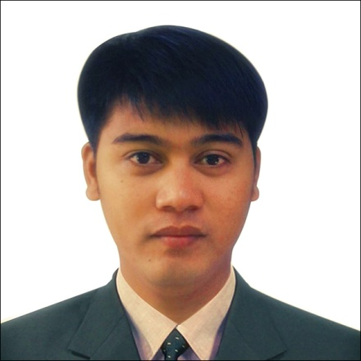
Purok 7, Nangka, Consolacion, Cebu
0922-613-3520
vicpepito03@yahoo.com

PROFILE SUMMARY

- Possesses good analytical and interpersonal skills
- Innovative/ creative problem solving
- Friendliness and the ability to get along with others
- Motivation, desire and willingness to learn

POSITION DESIRED

Any position slot that fits with my experience.

EDUCATIONAL BACKGROUND

June 2010 - March 2014 CONSOLACION COMMUNITY COLLEGE
BS in Hotel Restaurant Management

June 2009 - March 2010 Consolacion National High School

June 2003 - March 2004 Nangka Elementary School

WORK EXPERIENCE

Aug. 2011 - Jan. 2012 OJT House Keeping Orchard Hotel & Suite Perform Cleaning in the Room.
A. S. Fortuna St, Mandaue City, Cebu Perform Room bedding.
Replenish Room Amenities.

Nov. 2012 – May, 2013 On-call ( STEWARD)
Radisson Blu Cebu Assist cleaning the dishes.
Sergio Osmeña Boulevard, Perform cleaning in the kitchen.
Pope John Paul II Ave, Cebu

Nov. 2013 – Mar.2014 On-call Public Attendant
Marco Polo Plaza Cebu, Perform cleaning common toilet in the hotel.
Nivel Hills, Cebu Veterans Dr, Dust mopping and Floor buffing in the Hall Way.
Cebu City

May.2014 – Feb. 2016 Accounts Executive Embryo Trading & Jevan Industrial Sales Promote Productline.
B.B Cabahug St., Mandaue City, Cebu Conduct Price Quotation.
Facilitate client needs.

Oct.2016 – Jan.2017 Sales Representative Aries Distributor Inc,. Promote Productline. Sacris Road, Casunting Develop new accounts.
Mandaue City, Cebu. Assist client needs.

June,2017 – Present Area Sales Coordinator
Powerball Marketing Monitor availability of stocks in the Distributor.
Logistics Corp. Conduct Product awareness / Rekorida.
Ortigas Road, Pasig City Facilitate/ Schedule of Van driver and Merchandiser
Metro Manila. Develop new accounts as a new retailer of the Product.
Regular visit to existing client to listen regarding the
issue and concern.

SKILLS

- Sales Communication Skills
- Interpersonal Skills
- Management Skills
- Inventory Checking
- Computer Literate (MS Applications)
- Knowledge about Industrial Items
- Food, Hotel, and Restaurant Services

SEMINARS, TRAINING AND WORKSHOPS ATTENDED

March 2010 Parish Renewal Experience (PREX)
San Narciso Parish, Consolacion Cebu

February 2012 Fruit Carving
Consolacion Community College – Consolacion Cebu

January 2015 Bosch Powertools
Tipolo, Mandaue City

July 2018 Defensive Driving Seminar
Ortigas Center, Pasig City

