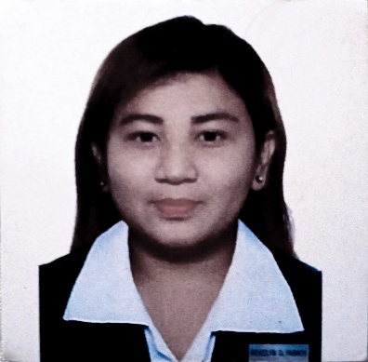
REVIELYN O. FABROS
Address: 65 Sampaguita Street, Clinic Ville Bf Homes, Paranaque City
Mobile no.: 09123972378
Date of birth: January 25, 1996
Place of birth: Malabon, M.M
Gender: Female
Citizenship: Filipino
Marital Status: Married
OBJECTIVE
To be able to develop an international perspective in order to live and work effectively to an increasing global society.
QUALIFICATIONS AND SKILLS
Computer Skills: typing,scan,copy/fax
Languages Spoken:English and Tagalog
Other Skills: Multi-tasking, Customer Service, Problem Solving
BACKGROUND
I am intellectually curious,a kind of employee who never stops learning.I am always looking forward to stay in the company in order to grow with the position.
EDUCATION
Institution Name: Speaker Eugenio Perez National Agricultural School
Location : San CarlosCity, Pangasinan
School Year : 2011-2012
Field of Study : Environmental/Agricultural Study
Institution Name: Access Computer College
Location : Aurora Blvd., Proj 3, Quezon City
School Year : 2012-2014
Course : Computer Science
Institution name: Apicius Culinary Arts and Hotel Management Consultant, Inc.
Location: LTBldg., 3rd Floor Dr. Arcadio Santos Avenue, Paranaque City
School Year: 2019
Field of Study: Classic Culinary Techniques and Cooking Method
WORK EXPERIENCE
Promoter | : | Sony PH and RCBC Bankard under CNT Promo and Ads Specialists Inc.  From June 2015 to October 2018
Customer Service Representative |  | : Infocom Technologies, Inc.  October 2018 to July 2019
Customer Service Representative : Telephilippines, Inc.
from December 2019 up to present
I hereby certify that the facts contain in this resume are true and correct to the best of my knowledge and belief.
Applicant's Signature

