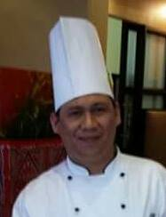
ROSELO A. SUPLAAG
96F Mendez Road, Baesa
Quezon City Philippines
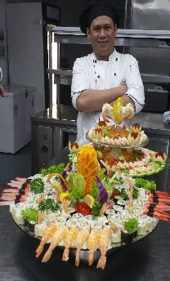

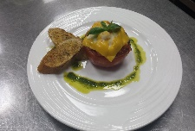
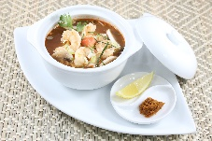
Contac t No: +639338528472/0540226107
Email ad: roselorussel_suplaag@yahoo.com



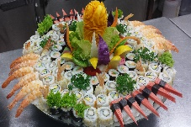

POSITION DESIRE: Head chef
OBJECTIVES:
Seeking any challenging position that would fit my knowledge, furthermore to enhance my skills in the field of which I may acquire and contribute my knowledge and I humbly possess for the additional success of your good company.

WORKING EXPERIENCES:
MOONLIGHT RESTAURANT AL JUBAIL BRANCH K. S. A
HEAD CHEF from July 06, 2015 to May 31,2020

- Over all in charge of kitchen operations including staff schedules and duties.
- Product development, introducing new recipes.
- Ensures that the daily operations of restaurant are running smoothly.
- Responsible for the efficient running of the kitchen area and directly in charge of the overall preparation of all the foods which are going to serve in the dining.

BLUEMAR RESTAURANT AL KHOBAR K.S.A
SENIOR SOUS CHEF from August 01, 2012 to July 05, 2015

- Responsible for the administrative operations cost control, hygiene, cleanliness, quality standards, supervision, and staffing training of kitchen staff.
- Supervise the kitchen staff.
- Responsible for making difference kinds of recipes for action cooking cuisines, Italian, French, Asian, Western, Mediterranean.

MOONLIGHT RESTAURANT AL JUBAIL BRANCH K.S.A
JUNIOR SOUS CHEF from July 21, 2010 to August 01, 2012
- Planning menu assured quality control and minimize waste.
- Create new recipe.
- Supervise the kitchen staffs to ensure the quality of the food
- Computes food costing.

DAR AL KARAM K. S.A
CHEF de PARTIE July 05, 2008 to July 10, 2010
- Food Production.
- Food and Stock Monitoring.
- Supervise the kitchen line station
- Ordering of ingredients from stock room and supplier.
- Food costing.

HEAVENLY URBAN CHEF
CHEF de PARTIE February 2007 to June 2008
- Food Production.
- Food and Stock Monitoring.
- Supervise the kitchen line station
- Ordering of ingredients from stock room and supplier.
- Food costing.

TERIYAKI BOY
SUSHI/COOK February 24, 2006 to January 17, 2007
- Food Production.
- Food and Stock Monitoring.
- Supervise the kitchen line station
- Ordering of ingredients from stock room and supplier.

EDUCATIONAL ATTAINMENTS:
College: STI College Fairview Diploma in Computer and Electronics Technology 2001-2003.
Secondary: Midsalip National High School, Midsalip Zamboanga del Sur
Primary: Midsalip Central Elementary School

TRAINING & SEMINARS:
- HACCP- Hazard Analysis Critical Control Point
(March 8-10, 2016 at Dammam Saudi Arabia – Level 2)
- HACCP- Hazard Analysis Critical Control Point
(Jan. 14-16, 2012 at Dammam Saudi Arabia – Level 1)
- Food Safety Basic Course
(March 02, 2015, Royal Commission of Jubail K. S. A)
- Basic Culinary Training
(April 01-30, 2005 at Congo Grill, Scout Albano, Quezon City, Philippines)

PERSONAL DATA:
Age: 38 yrs old
Date of birth: July 08, 1981
Place of birth: Pob. A Midsalip Zamboanga del Sur
Gender: Male
Height: 5’7
Weight: 80kg
Religion: Roman Catholic
Citizenship: Filipino
Marital Status: Married
Passport Number: P3586577B

